Spring & Microservices Training

1. Spring Core
2. Hibernate
3. Java 8
4. GIT
5. Spring Boot & Microservices

Spring Framework

Framework: It allows you to quickly develop the applications by providing lot of inbuilt features like Type-conversion, Exception Handling, Design Patterns, Transaction, Security, Internationalization and so on.

Spring Framework: It allows you to develop different types of applications like desktop, web applications, enterprise applications, mobile application, cloud based application, it provides lot of modules to develop the applications

Some spring framework modules

1. Core Spring: Basic Building block for all the spring technologies/modules
2. Spring MVC: It is used to develop web applications
3. Spring REST: It is used to develop REST API’s
4. Spring Boot: It will automate the spring development
5. Spring Cloud & Microservices: It used to deploy spring applications on cloud

Spring Core:

It provides you the alternate way of creating the dependent objects which is nothing but dependency injection, here the objects that are dependent on other objects are maintained by the spring and supplies to the dependents with very less changes in the application code.

Dependency Injection: It is an alternative way of creating the dependencies that are supplied to other dependent object

Environment setup

Java 8  
Eclipse  
MySQL  
Postman client  
Git.

Spring Framework helps in resolving the object dependencies through Dependency Injection feature where it creates the dependencies and maintains in its container called IoC(Inversion of Control)

IoC: Since the operation is inverted its called as Inversion of Control

How to implement the Dependency Injection in Spring Framework

1. Create Java Maven Project
2. Add the Spring Libraries in pom.xml: to configure the jar dependencies
3. Spring Configuration XML file: to configure the object dependencies.

pom.xml

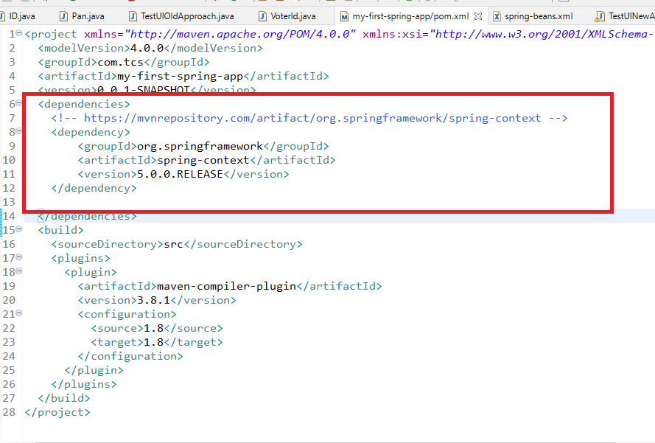

ID.java

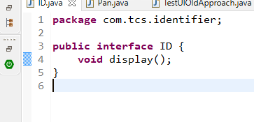

Pan.java

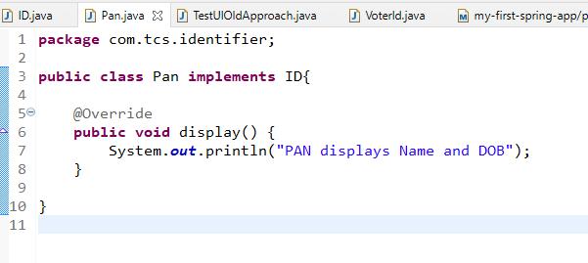

VoterId.java

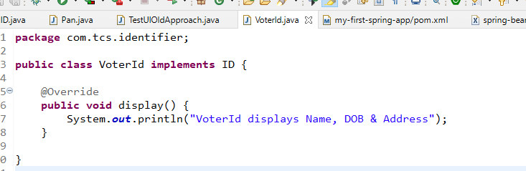

spring-beans.xml

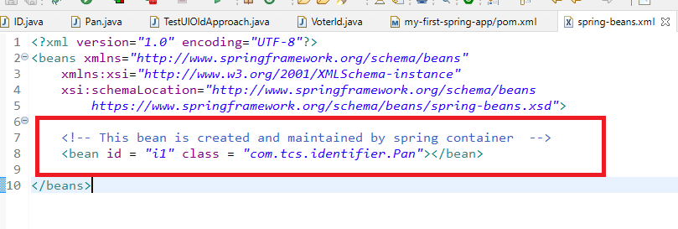

TestUIOldApproach.java

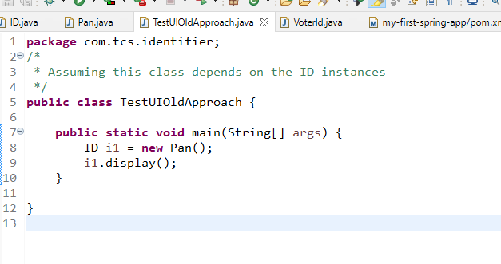

Here if you want to use the another implementation object you will change the code at 8th line but with new approach of using the dependency injection you don’t have to change the client code

TestUINewApproach.java

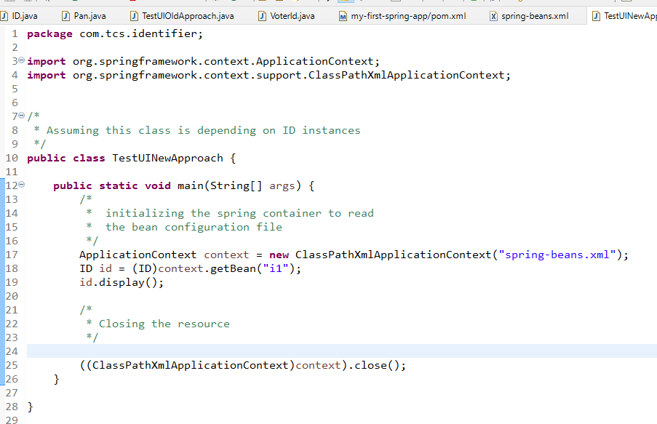

Here the spring framework is going to create the objects based on the configuration done in the xml file and getBean() returns the object having the id from the container, now you can change the implementation instance in the XML file without changing the code in TestUINewApproach.

Types of Dependency Injection

1. Setter Injection: Supplying the dependencies through setter method
2. Constructor Injection: Supplying the dependencies through constructor parameter

Assume you have Datasource & CustomerDAO which are having some dependencies

class Datasource {   
 url, username, password;

setters & getters  
}   
class CustomerDao {   
 Datasource ds;

setters & getters   
}

In Old approach

Datasource ds = new Datasource();  
ds.setUrl(url);  
ds.setUsername(username);  
ds.setPassword(password);

CustomerDao dao = new CustomerDao();  
dao.setDatasource(ds); // initializing datasource via setter

dao.connect(); // connects to database

(or)  
CustomerDao dao = new CustomerDao(ds);// via constructor

dao.connect(); // connects to database

New approach is using dependency injection

You don’t have to create object and supply the dependencies, because spring framework does that for you.

In xml file only you can configure the dependencies where datasource can be supplied to the DAO

CustomerDao dao = ctx.getBean(“dao”);  
dao.connect();

Setter Injection: It is the process of initializing the properties or dependencies through setters but framework calls the setters by using the values configured in the XML file, you will use <property> tag for setter injection

Constructor Injection: It is the process of initializing the properties or dependencies through constructors but framework calls the constructor by using the values configured in the XML file, you will use <constructor-arg> tag for constructor injection

Setting Datasource to the CustomerDao and calling connect methods

pom.xml

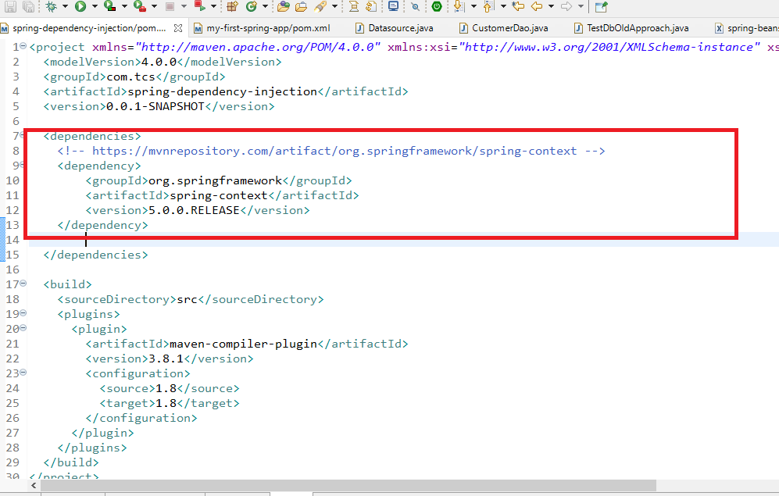

Datasource.java

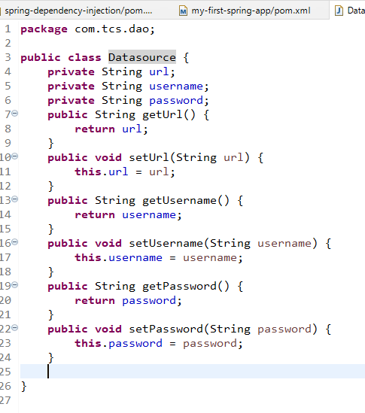

CustomerDao.java

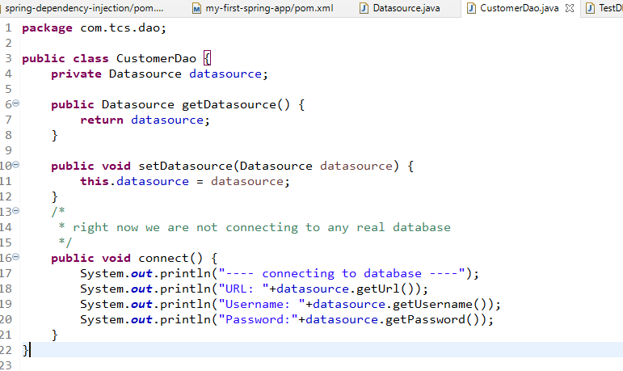

spring-beans.xml

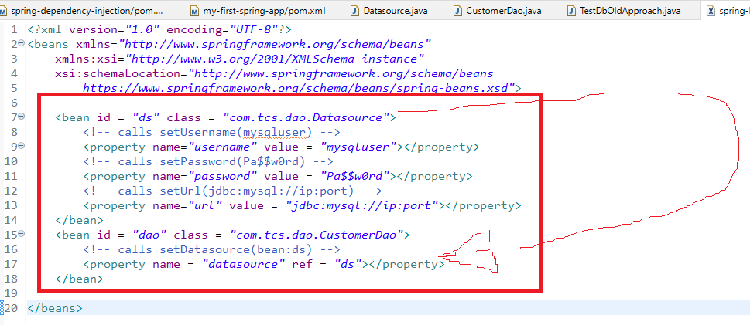

TestDbNewApproach.java

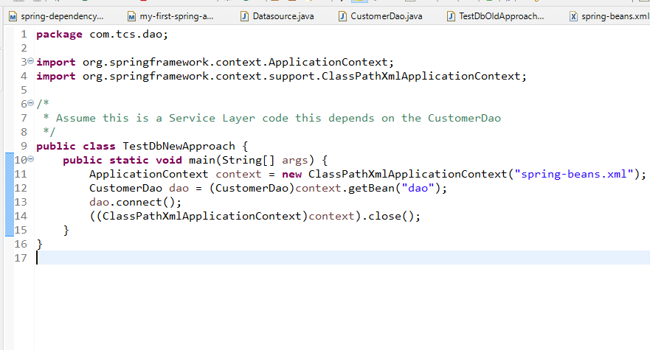

Constructor Injection

Initializing the properties of an object through constructor parameter.

Assume you have a service that depends on dao which inturn depends on datasource in that case you can configure the properties via constructor also by using <constructor-arg>.

Since Datasource & DAO are configured through setter injection, we can configure the CustomerService via constructor-injection

CustomerService.java

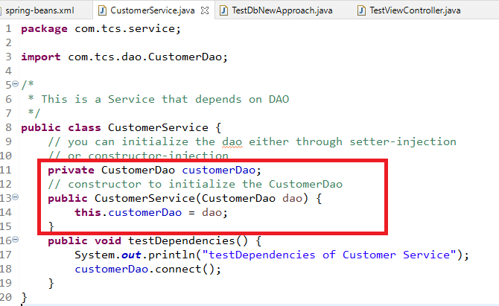

spring-beans.xml

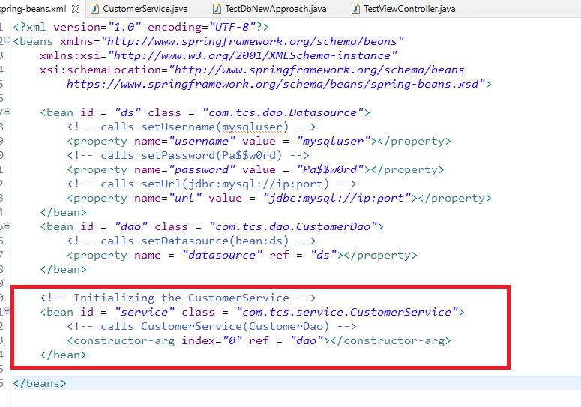

Now the CustomerService is fully ready with its dependencies

TestViewController.java

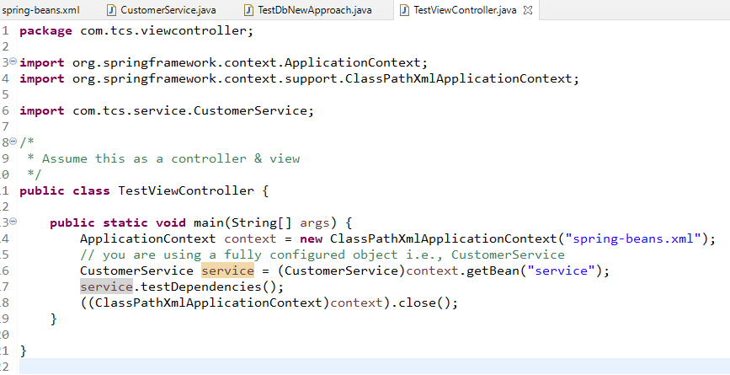

The above program is performing dependency injection via setter & constructor, this makes the application loosely coupled however to implement loosely coupled program you need to use interface references in place of class references.

Bean Scopes

By default the bean is singleton, means only one instance per <bean> configuration, however if you insist to have multiple instances per <bean> then you need to change the scope to “prototype”

<bean id = … class = … scope = “prototype”>

The bean will be instantiated for every getBean call

Test.java

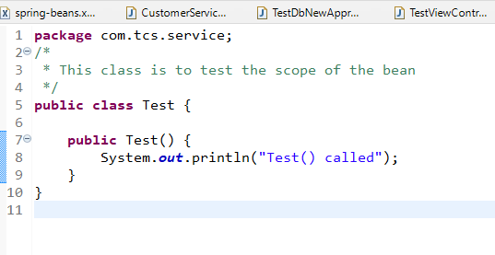

spring-beans.xml

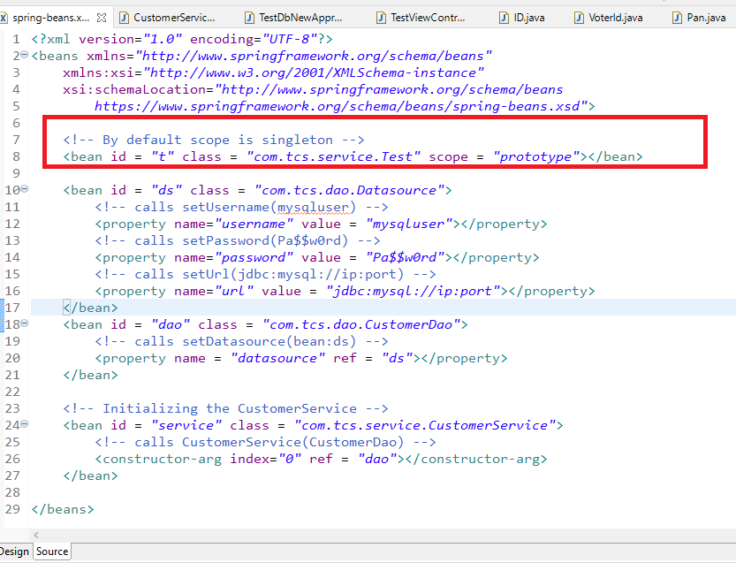

TestScopes.java

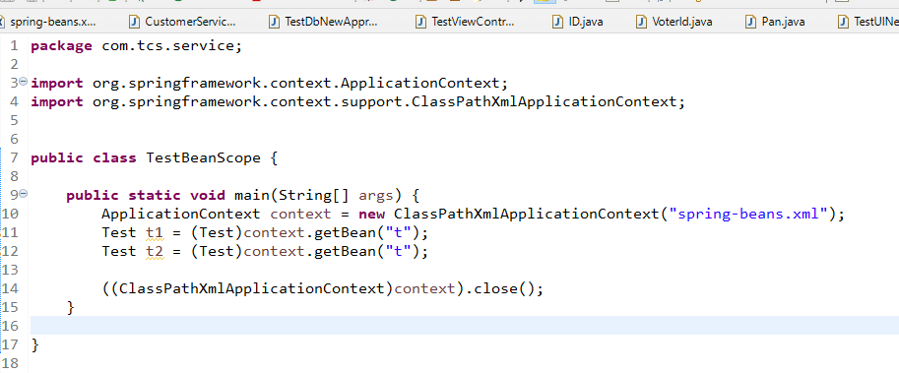

Output:

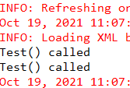

Test() called prints twice because for every getBean() a new instance is created this is because of scope prototype

Spring Annotation

You can use annotations in place of XML to configure the beans which is much simpler compare to XML configuration.

Spring provides annotations which creates the object for the bean they are:

@Component: Normal bean class

@Service: For Service classes

@Repository: For DAO classes

@Controller: For Controller classes

@RestController: For classes having REST API’s

To supply the object to another object we have an annotation

@Autowired

Datasource.java

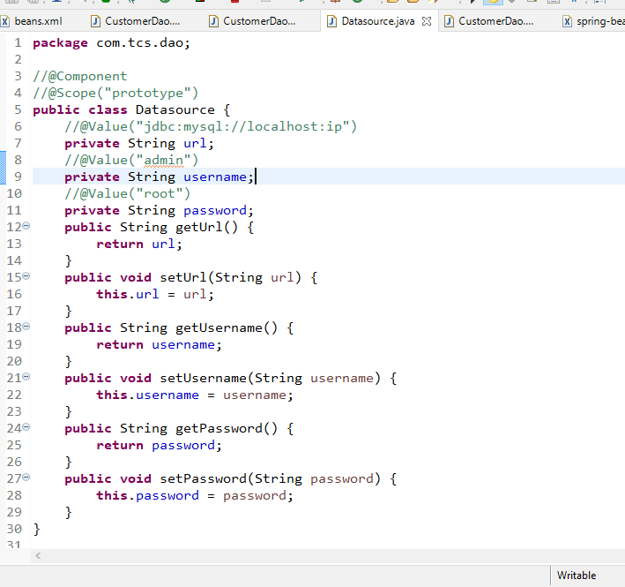

CustomerDao.java

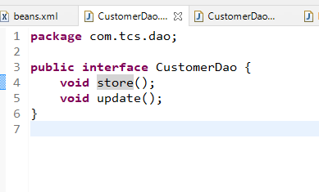

CustomerDaoImplV1.java

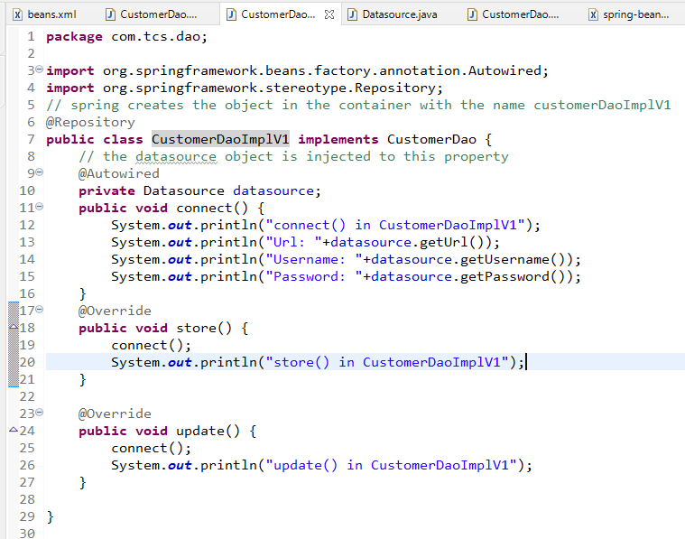

CustomerService.java

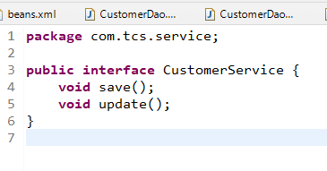

CustomerServiceImplV1.java

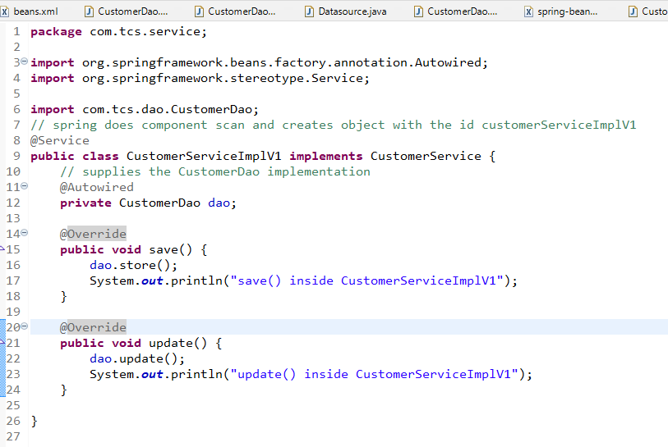

TestViewController.java

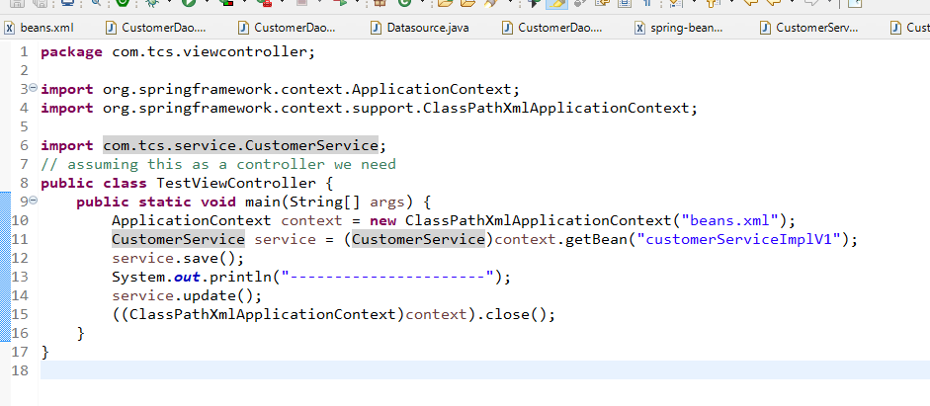

beans.xml

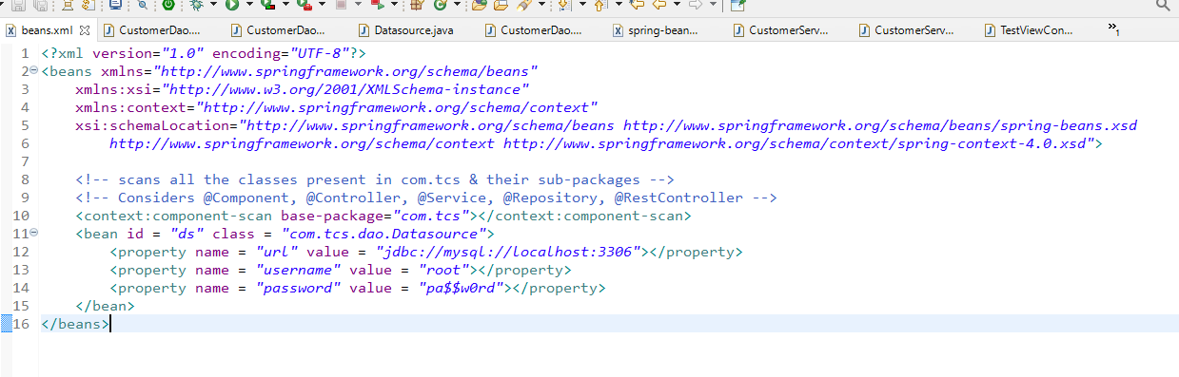

Hibernate:

It is an ORM framework used to interact with the database

ORM (Object Relational Mapping) can map java objects directly to the database tables.

To map the java objects to the table you need entity classes.

Entity classes: These are classes with @Entity annotation, which provides table information like to which table class instance must be mapped, to which column the properties of the object must be mapped, which property acts as a primary key.

Rules while using hibernate

1. You must have an entity class
2. You must have an hibernate.cfg.xml file that will have datasource informations like username, url, password, database driver and etc

Database Drivers: These are libraries which are released to interact with the particular database

ex: MySQL Driver can interact with MySQL Database, Oracle Driver can interact with Oracle Database.

Hibernate Project

pom.xml: hibernate & database libraries

hibernate.cfg.xml: database credentials, drivers & entity class configurations

Entity classes: These are java beans that are mapped to the appropriate table of the database

Client Program: This performs CRUD operation

Step to interact with the database

1. Create the table in mysql database

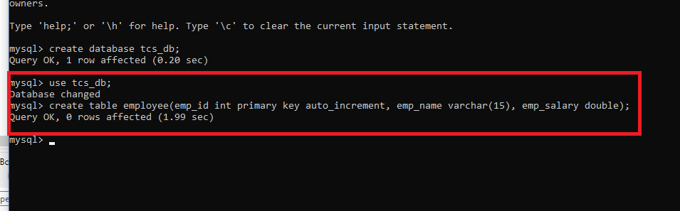

1. Create a java project & convert it into maven project
2. Add hibernate-core & mysql-connector libraries
3. Create an hibernate.cfg.xml file and enter datasource informations
4. Create entity class for the Employee table
5. Create client program to perform CRUD operations

pom.xml

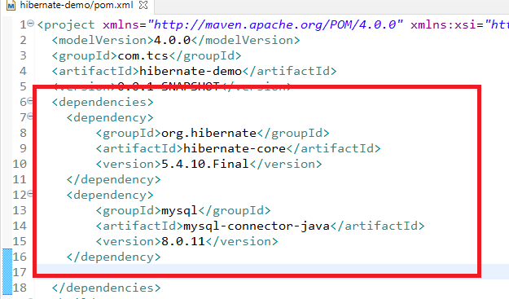

Entity class to provide the table structure

Employee.java

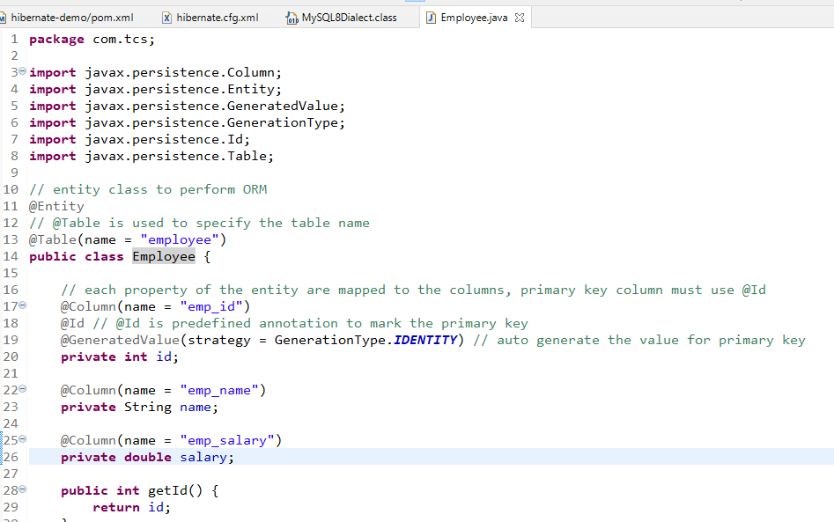

hibernate.cfg.xml

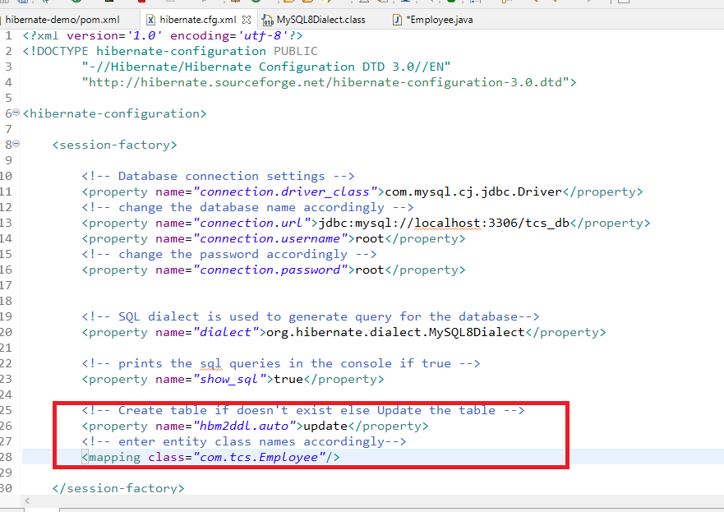

Client program to perform CRUD operations

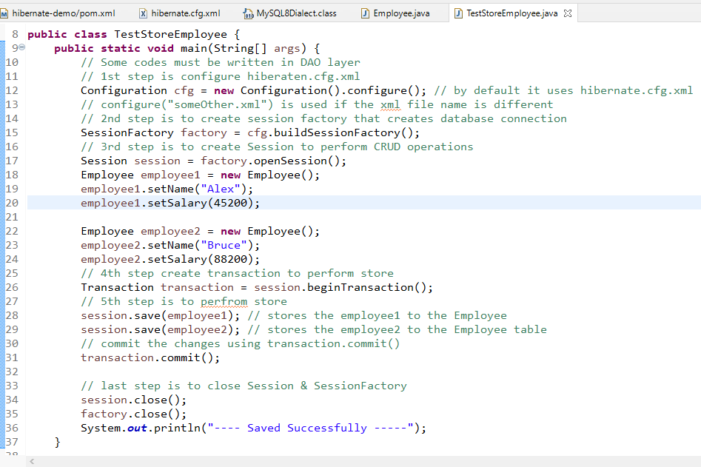

Some of the methods in Session

save(Object): to store the entity

get(primary_key, class): to retrieve the entity based on the primary key

update(Object): to update the entity

delete(Object): to delete the entity

createQuery(query, class): to write customized query in JPQL/HQL which is a query language written to the entity

Since all the database logics must be part of DAO we can create a DAO with methods to perform CRUD operations.

Creating a class to return the SessionFactory

HibernateUtil.java

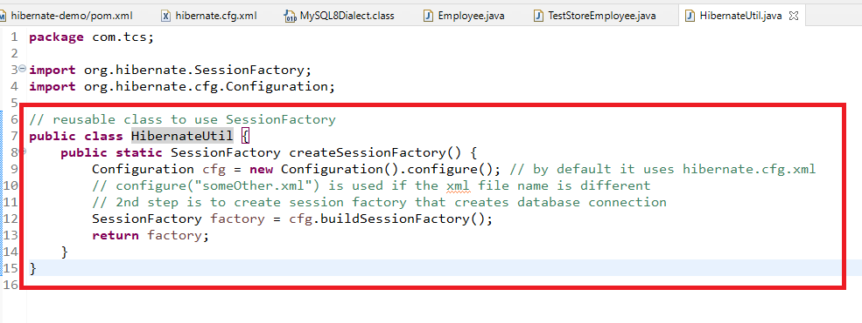

Using this createSessionFactory() whenever you need SessionFactory instance

TestStoreEmployee.java

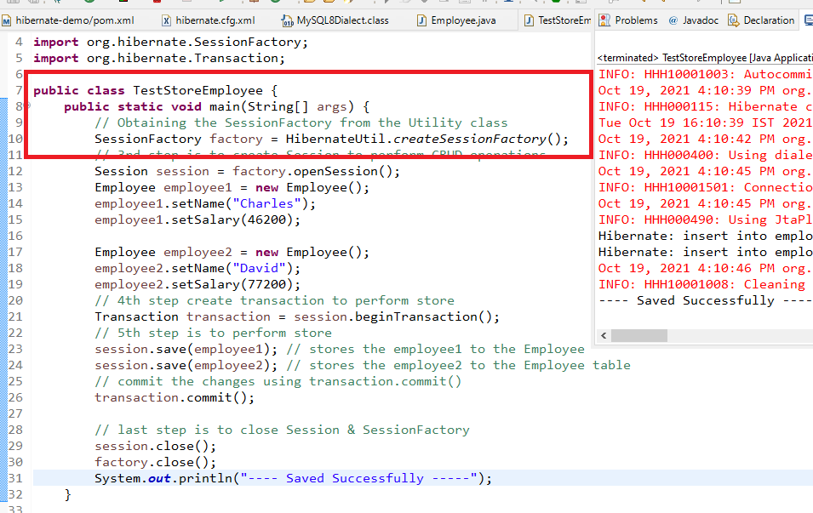

EmployeeDaoImpl.java

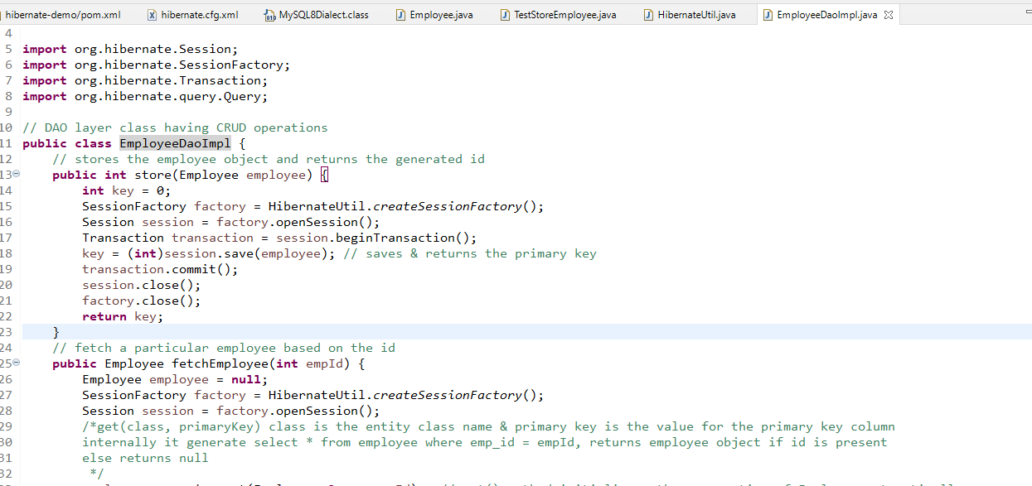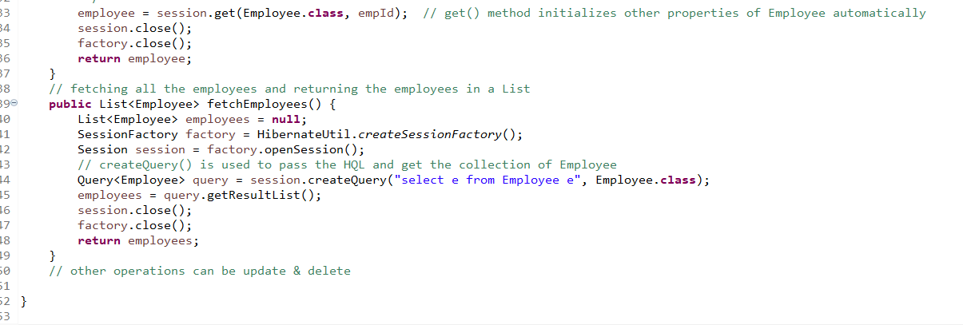

The above DAO class can be instantiated in the Service Layer to perform the CRUD operations, but we can use ViewController in place of Service

EmployeeViewController.java

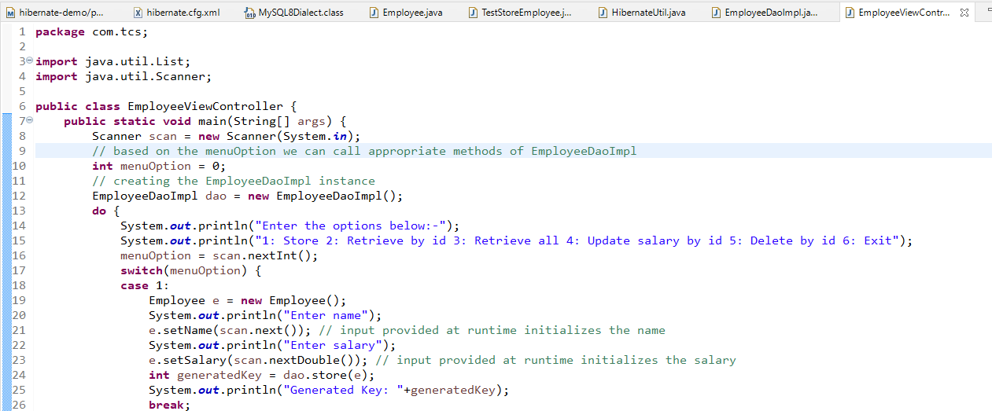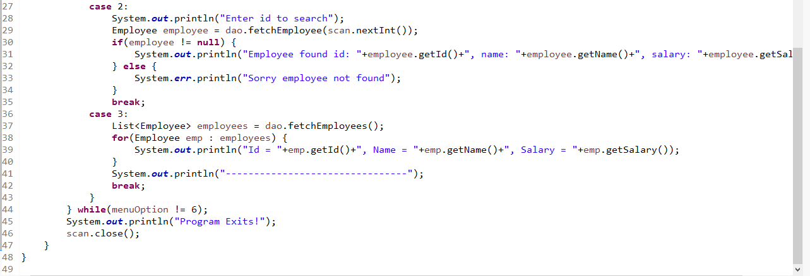

Integrating Hibernate & Spring

Spring provides some libraries using which you can also integrate with other frameworks ex: Hibernate, it provides a library called spring-orm using which you can use hibernate features in your spring frameworks.

Advantages of using spring with orm

1. You get all the dependencies required to interact with the database, you don’t have to create any Configuration, SessionFactory, Session, Transaction and so on.
2. Spring Frameworks provides you a fully configured object to perform the CRUD operation and spring takes care of connecting to the database and also closing the resources
3. Spring provides an object called HibernateTemplate which is used to perform the CRUD operations, you don’t have write code to load the xml, obtain the SessionFactory, obtain the Session and Transaction, also using commit(), close() are all not necessary
4. Using HibernateTemplate you can directly call save(), update(), get(), delete()

Steps to integrate spring with hibernate

1. Add following dependencies
   1. spring-context
   2. spring-orm
   3. hibernate-core
   4. mysql-connector
2. Configure the Spring Bean Configuration file to use the fully configured HibernateTemplate i.e., dependencies to be supplied to the HibernateTemplate

Note: You don’t have to use hibernate.cfg.xml file, because spring configuration file is sufficient to mention hibernate informations

1. Create DAO class & Entity class

pom.xml

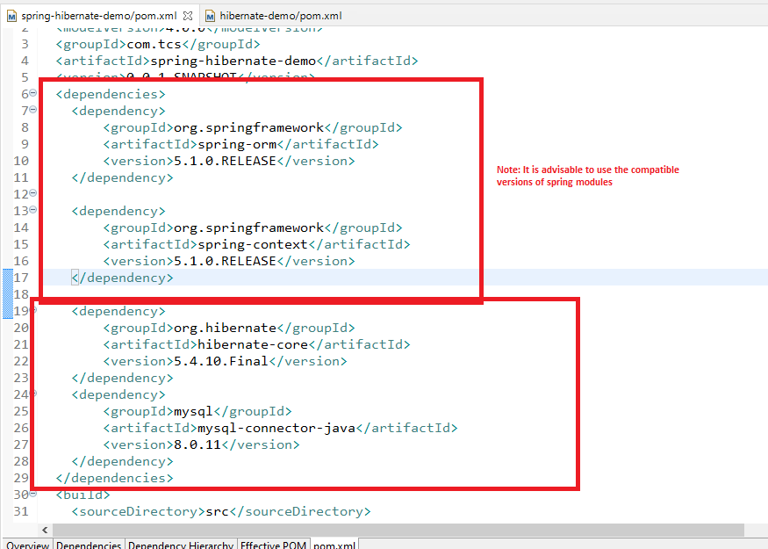

Spring Bean configuration file to configure the datasoruce, important this is the configuration file must have tx namespace while using spring-orm features

beans.xml

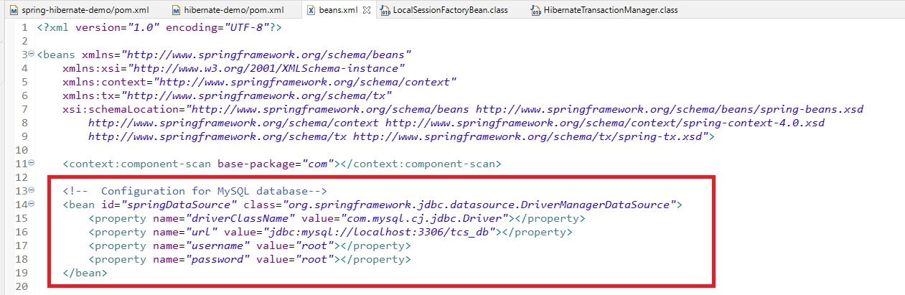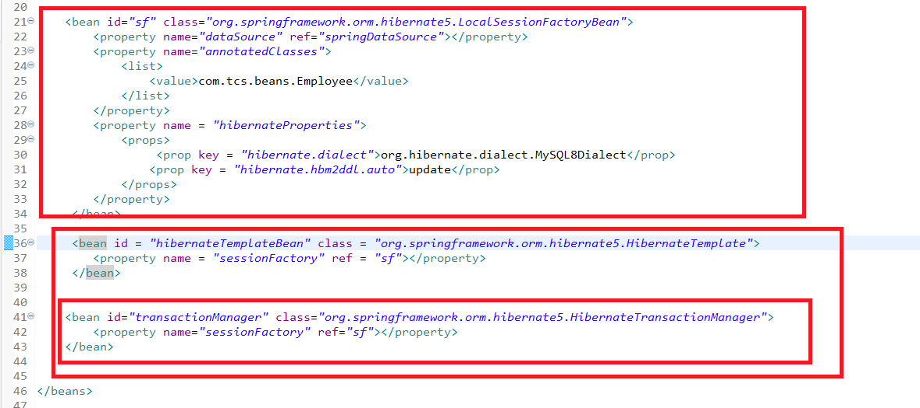

Here the application uses HibernateTemplate to perform the CRUD operations but HibernateTemplate needs SessionFactory that will connect to the database & generate the query according to the dialect and it needs Datasource object to connect, Spring takes care of Transaction & establishing connection, cleaning up the resources, you will get an object that is fully configured.

HibernateTemplate is present in the container which you can get it by @Autowired or through getBean(), however we will use getBean() in the ViewController to use the Service instance, it means you can create Dao with @Repository Service with @Service and a ViewController, here we are going to inject HibernateTemplate to the DAO, inject DAO to the Service and inject Service to the Controller/ViewController

The dependencies flow would be this way.

Datasource -> LocalSessionFactoryBean -> HibernateTemplate -> EmployeeDao -> EmployeeService -> ViewController

Employee.java

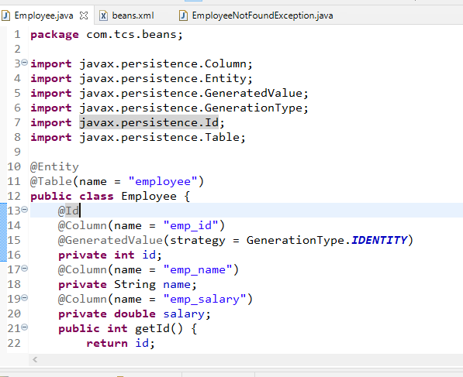

We can create a checked exception and throw it when employee is not found.

EmployeeNotFoundException.java

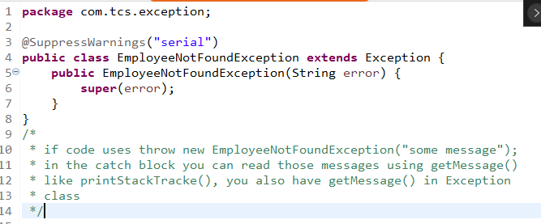

Creating an interface in the dao

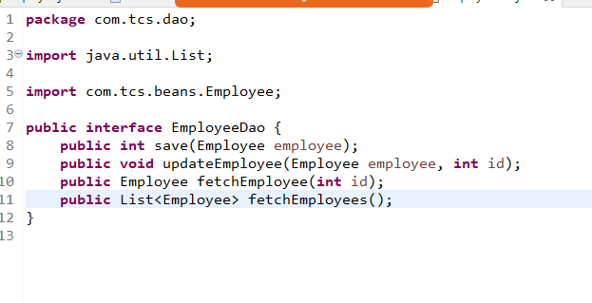

Implementing the Dao layer by suppling the HibernateTemplate using @Autowired, use @Repository in DAO so that spring container creates the instance of DAO

EmployeeDaoImpV1.java

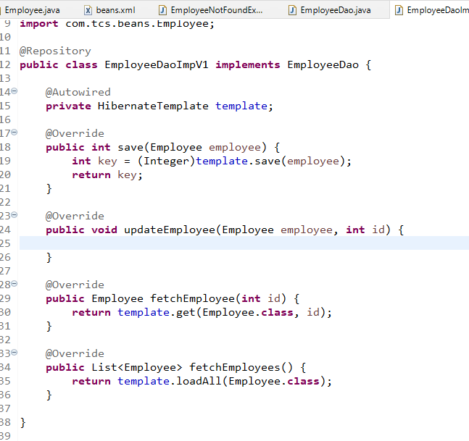

Create Service interface

EmployeeService.java

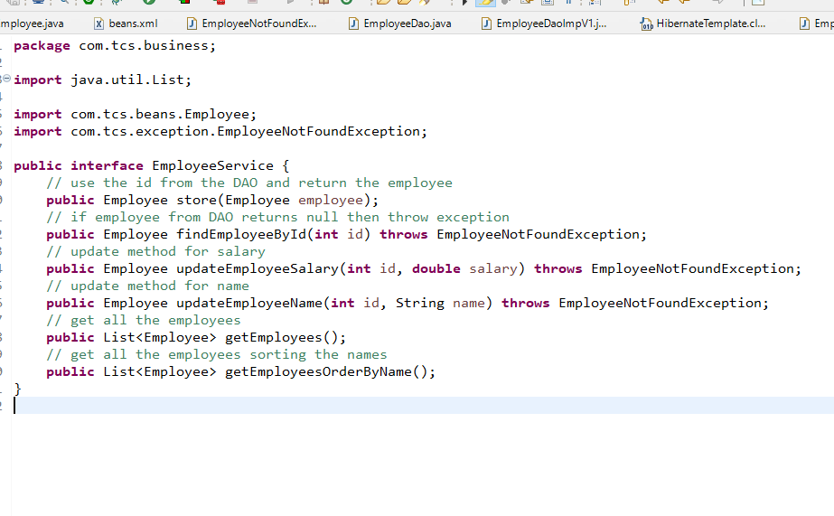

Implementing the service layer by injecting dao instance

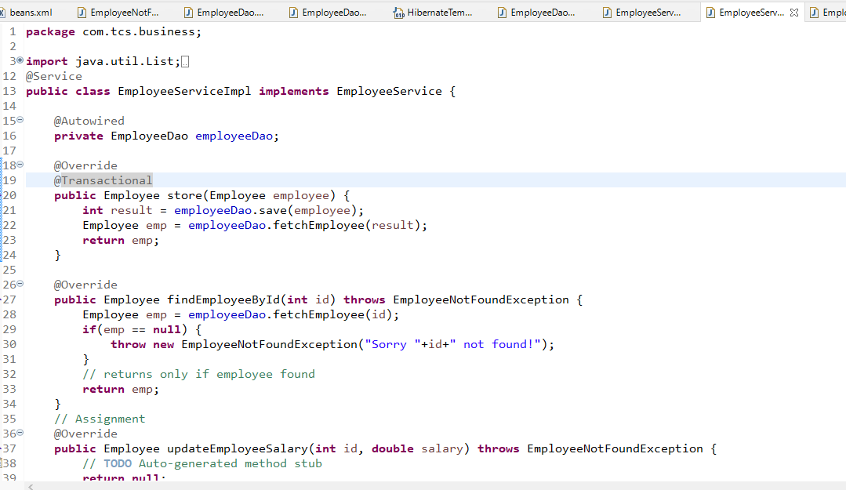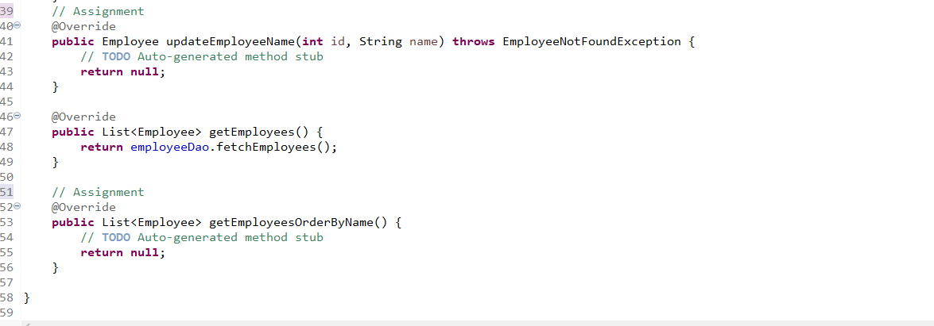

EmployeeViewController.java

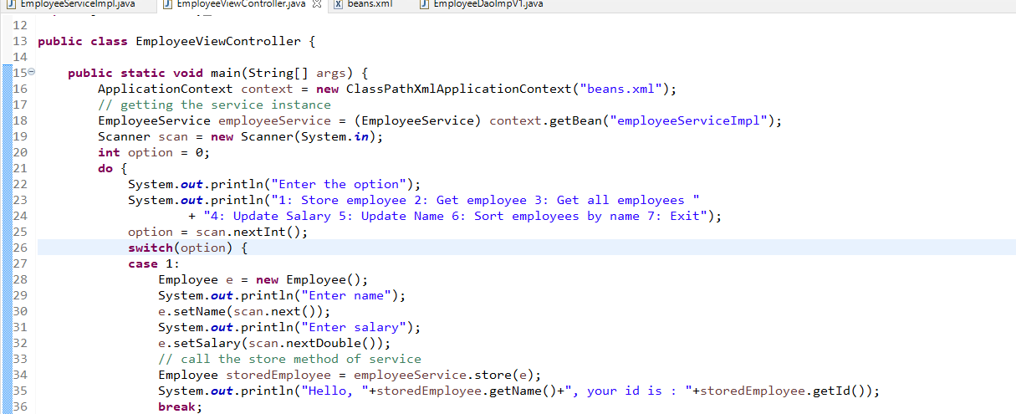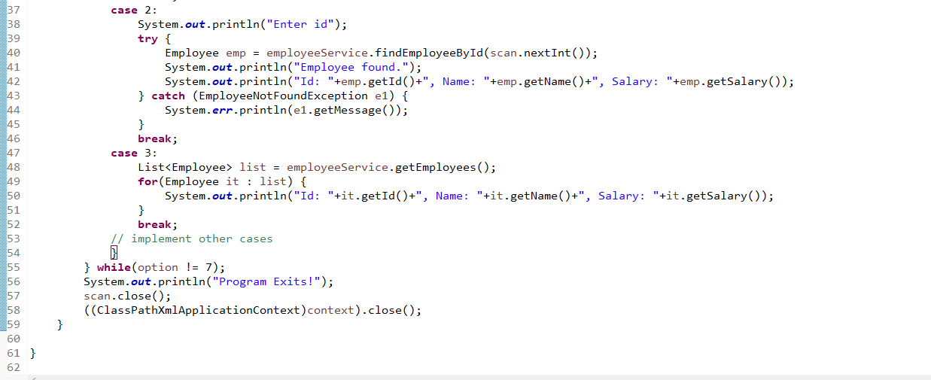

Exercise: Implement other methods of DAO, Service and cases in ViewController

Note: Use Comparator to sort the employee name in the Service layer

Java 8 Features

1. Static & Default methods in the interface
2. Lambda expression
3. Functional programming with Functional interface
4. New Date & Time API’s
5. Streams to process the huge data

Static & Default methods inside the interface

From Java 8 onwards you can have default implementations and static methods in the interface, this would be useful when an old interface need some new methods but without breaking the contract you want to add these new methods.

Default methods: It will have the default implementation it will have a default keyword, which you can override in the subclass if you want.

Static methods: It can’t be overridden, but you can call using interface name

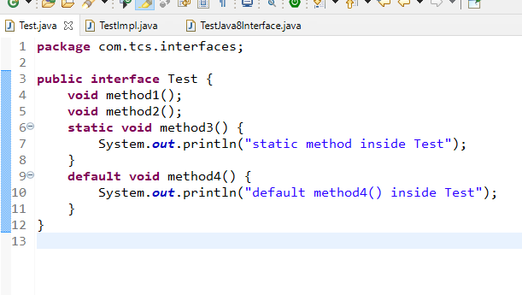

TestImpl.java

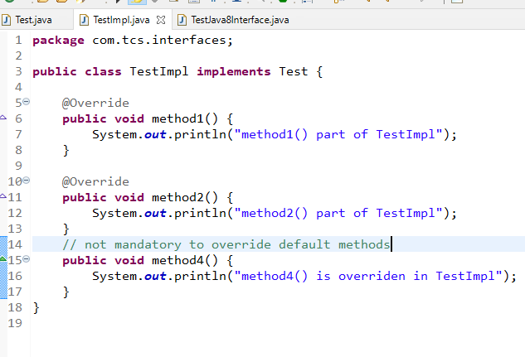

TestJava8Interface.java

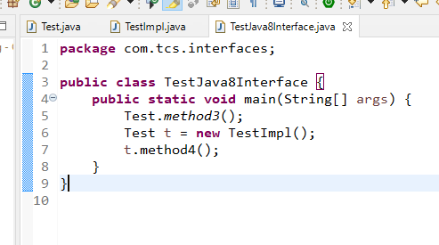

Functional programming with functional interface

It allows you to pass the function as a data to an object, Before Java 8, in Java you can only pass data to the object but not the function as a parameter i.e., you can’t pass function as a parameter, Many programming languages like Python, Javascript supports passing function as a parameter that enables to perform callback functionalities.

In Java 8 you can achieve functional programming which allows you to pass the code as a parameter instead of only passing object, it can be achieved using the functional interface.

Functional Interface

These interfaces will have only one abstract methods, so that when you want the method to be implemented you don’t have mention method signature and create any class, without using class and method name you can implement it.

Earlier:

interface Xyz {   
 void test1();  
}

// implementation is done using class

class XyzImpl implements Xyz {   
 public void test1() { …. }   
}

// using the Xyz reference

Xyz x = new XyzImpl();  
x.test1(); // test1() will be called on the XyzImpl

Now:

interface Xyz {   
 void test1();  
} // treated as functional interface

In java8 you can implement such interfaces using simple expression which is called as Lambda Expression

Xyz x = () -> { … }

x.test1(); // calls the implementation in the lambda expression

Calculator.java

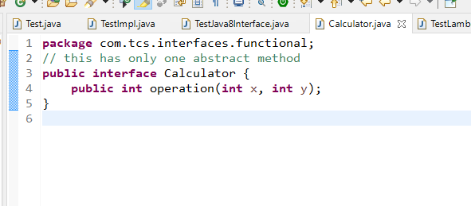

TestLambdaExpression.java

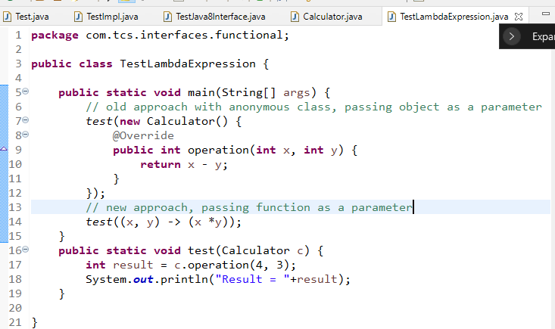

You can use such lambda expression in all the functional interfaces like Comparator, Predicate, Consumer, Supplier, Runnable and etc.

Some important points with lambda expression:

() -> “Hello World”: 0 parameter method returns string

(a, b) -> (a + b): 2 parameter method & returns addition of 2 variables or concatenation of 2 variables

() -> return “Hello World”: Invalid lambda

() -> { “Hello World” } : Invalid lambda

() -> { } : Valid lambda because method return type is void

() -> 10: Valid lambda returns int

() -> { 10 }: Invalid lambda doesn’t know what to do with 10

Using Lambda in Comparator

Comparator has one abstract method i.e., compare(Object, Object) taking 2 parameters

Item.java

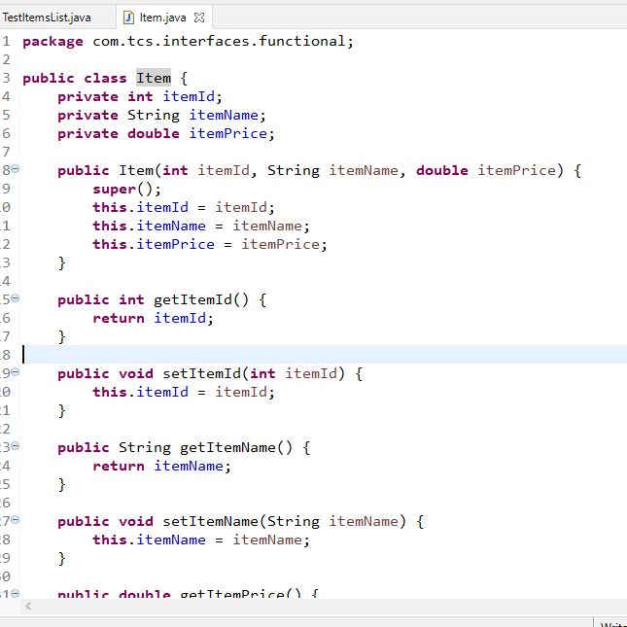

TestItems.java

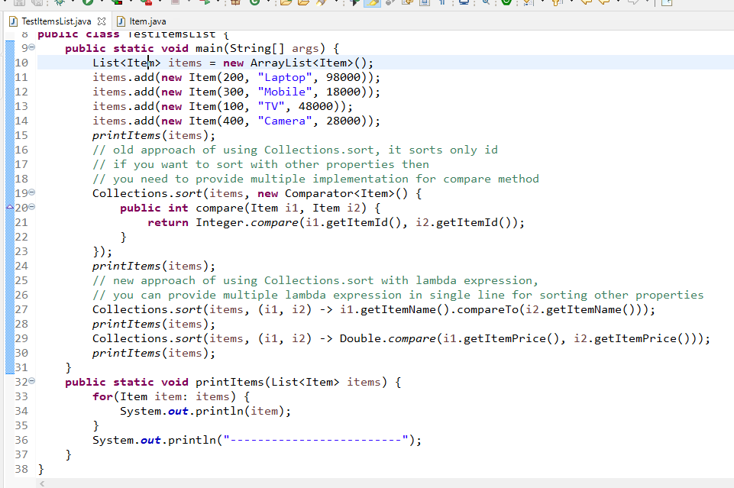

Date & Time api’s in Java 8

Old date & calendar classes are deprecated for obvious reasons, hence Java released 3 new classes to work on date & time which are:

1. LocalDate: Only for date
2. LocalTime: Only for time
3. LocalDateTime: For both date & time

All the classes follow the global ISO standard to represent the date & time i.e., yyyy/MM/dd and hh:mm:ss

Drawbacks of Old Date API’s

1. Date gives date & time both
2. Most of the methods give wrong results ex: getYear() returns the result by subtracting 1900 with current year, i.e., for 2021 getYear() gives 121
3. Calendar is introduced but some methods still give results which are not convincing ex: month starts from 0 i.e, getMonth() gives 9 for October instead of 10

TestDateTime.java

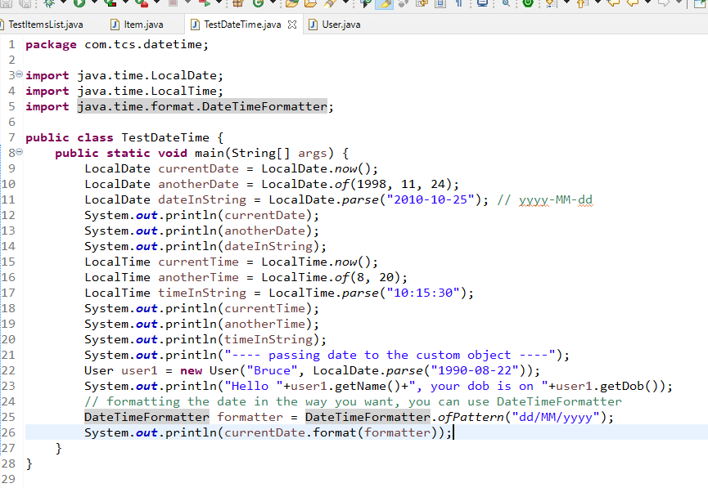

User.java

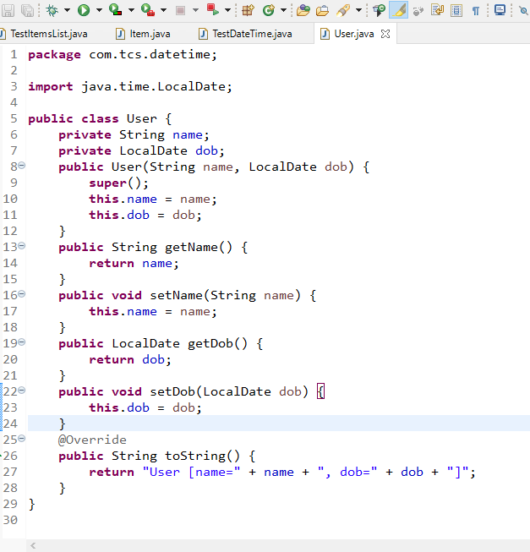

Output:

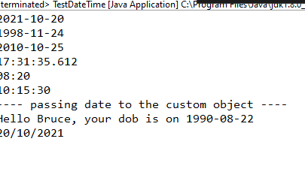

Exercise: Implement lambda expression in the spring & hibernate program to sort the name i.e., getEmployeesOrderByName()

Java 8 Streams

It is used to process the huge collection of objects in a declarative way through lambda expression.

Streams have various methods that can be used in pipeline to get the result which can be again given another method to get the result until you want the final result.

Pipeline means: You can call the method in chain

i.e., list.stream().filter().sort().forEach();

Here stream() creates the data to apply stream methods, filter() gives the result by applying some condition on the data, the stream you get from the filter is passed to the sort that gives the result which will have data sorted, later forEach() takes the result and iterates.

Stream doesn’t modify the existing data structure, it gives you the result as per the pipelined operations which you can use in another data structure.

Some of the methods in Streams that can be used for intermediate operations are:

filter()

sorted()

map()

Some of the methods in Streams that ends the operations

forEach()

collect()

Dish.java

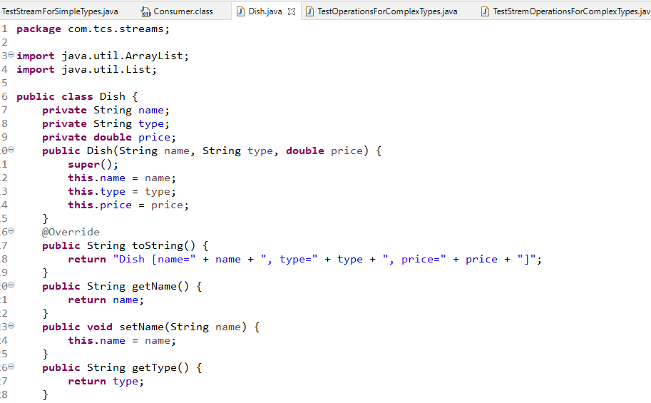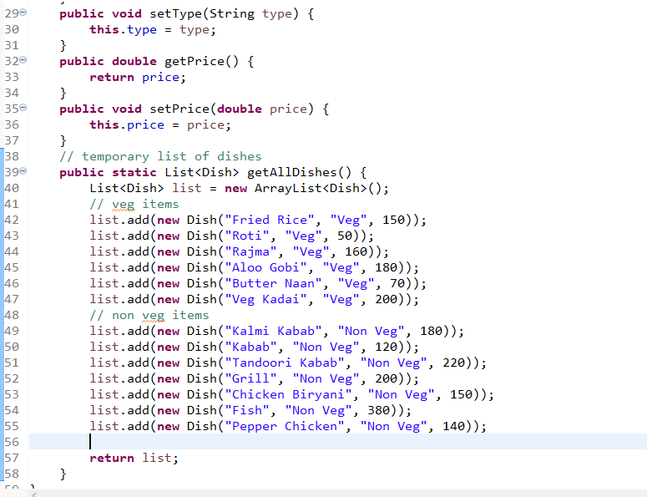

TestOperationsForComplexType.java

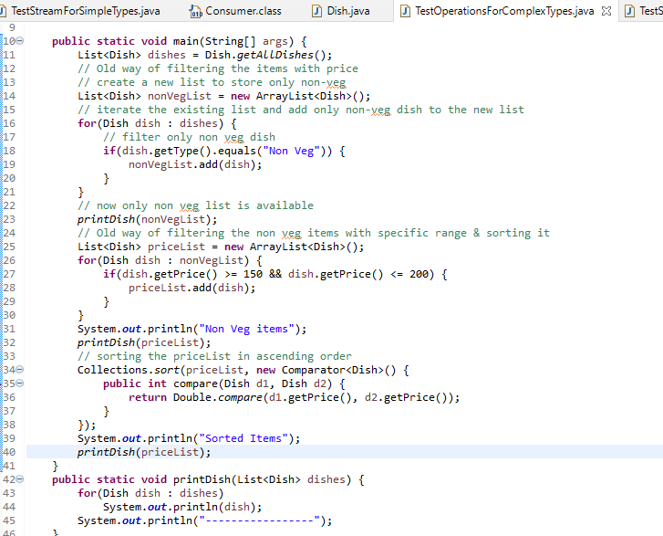

Here we have written lot of code to perform various operations like filtering, sorting and iterating, that can be reduced through Java 8 Streams.

TestStreamForComplexOperations.java

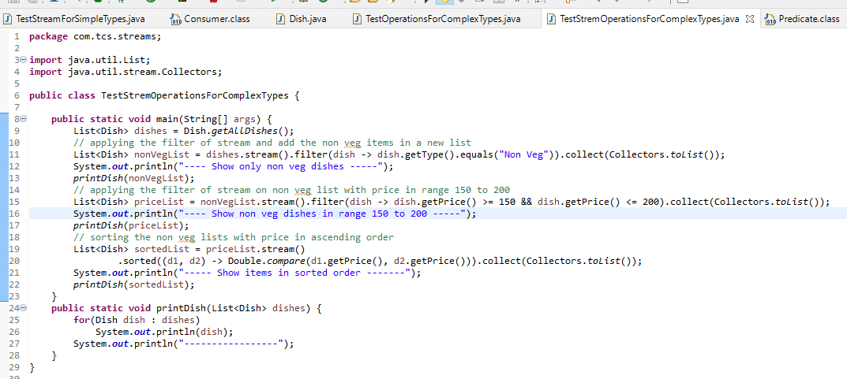

map(): It is used to produce the result from the stream with some operations

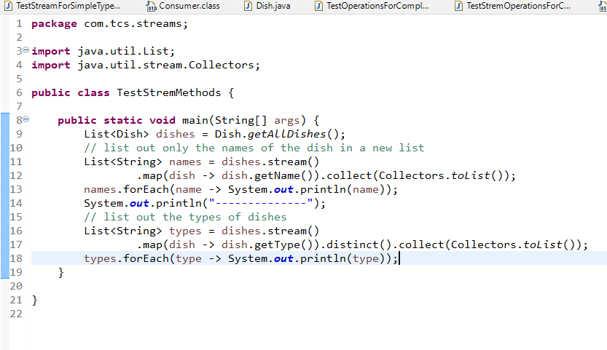

Method Reference

It is used for functional interface when you want to provide the implementation which is already existing instead of creating the new implementation

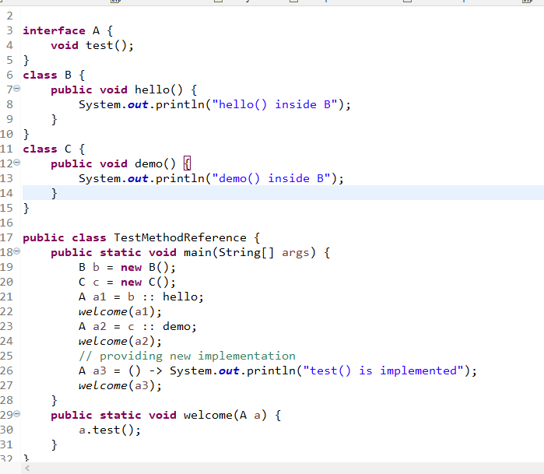

Git: It is a version controlling system, which allows users to collaborate their work, so that every user will have other users work in their machine.

Git provides two repositories one in git hub which is called as remote repository and another in user’s machine which is called as local repository.

Git Branches: It is a feature that will have the work of the user and maintains the history, by default GIT will have a master branch which or main branch that will have the history of work, the users can work in the main branch if he is a single user, if there are multiple users then its better to create user defined branch and work in the user define branch

Some of the commands in GIT

git init: to create a git repository in local machine

git clone: to clone the remote repository

git push: to push the local repository to the remote

git pull: to pull the changes from remote repository and update the local repository

git status: to list the changes done in the local repository

git add: to add the changes to the staging area (intermediate location) between local & remote

git commit: to commit the changes added in the staging area.

Rules while working in GIT

1. Always do the changes in the custom branch not in the master/main branch
2. Push the custom branch to the remote repository and merge the custom branch with the master branch of remote
3. If there’s a conflict in merge, pull the master of remote to the local repository branch and merge the custom branch with the master branch which is pulled and then push the custom branch

Steps to update the remote repository

1. Ensure that you are working in custom branch using git checkout branch-name
2. Add the changes to the staging area using git add path
3. Commit the changes of staging area using git commit -m some-message
4. Push the changes done in the custom branch to the remote repository
5. Some one in the Team would merge your custom branch with the master branch in the remote repository

Ways to create local repository

1. Create .git folder using git init in the local machine
2. Clone the Remote repository from the GIT Hub using git clone

Steps:

1. Creating local repository using git init

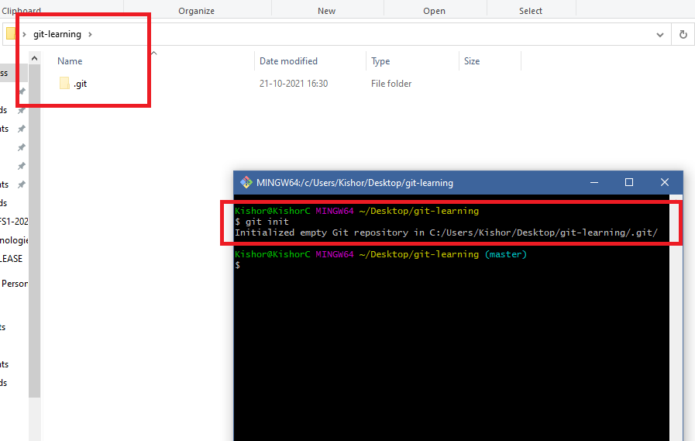

1. Notice you are in master/main branch,

Note: developers should never do any changes in the master/main branch not even a single dot in any file must be written in master/main branch

1. An empty repository can have some Readme files before checking out to another branch
2. Create a Readme.txt file

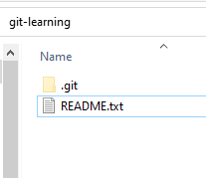

1. Staying in master branch add the file to the staging area & commit the changes

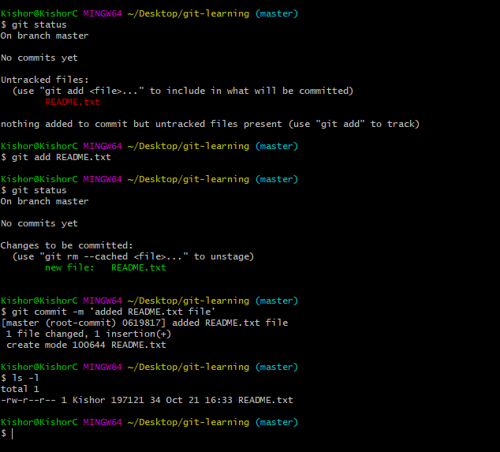

You can’t push this to the remote repository because local repository is not linked to the remote repository

1. Link Local Repo with Remote Repo by creating a remote repository or copy the URL of the remote

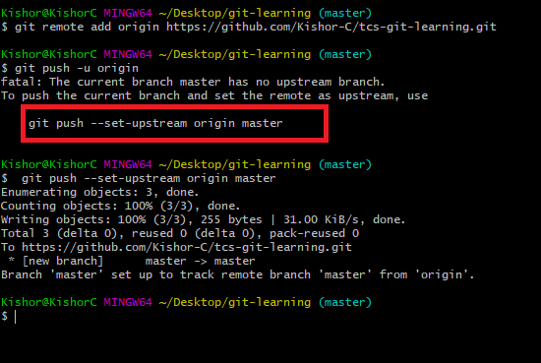

Note: There’s not commits in the Remote you need to use get push --set-upstream origin master for the initial push

later onwards you can use git push -u origin <branch-name>

Creating the branch

git branch issue12

Checkout to the branch

git checkout issue12

Make some changes in the branch and add the changes to the staging area

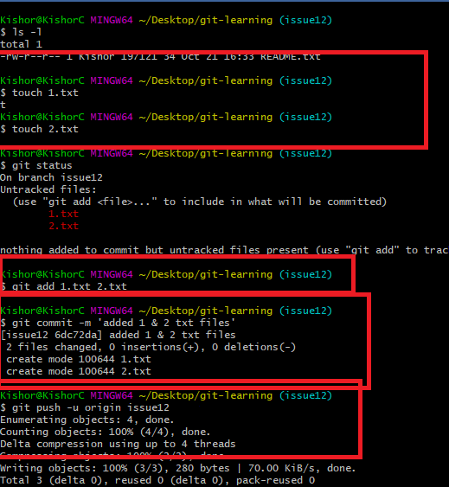

Now in the Remote repository you will see the Pull request, which can be merged if there’s no conflict else you can’t merge so you need to close the pull request & notify the user who pushed to resolve the conflict and push

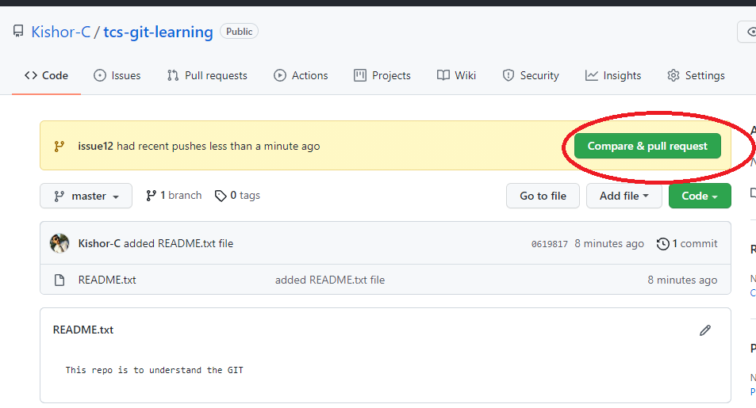

Some one in the team will have a responsibility to compare custom branch with master/main branch and will merge if there’s no conflict if the merge is success the custom branch can be deleted and the user can also delete the custom branch & pull the master branch from the remote repo.

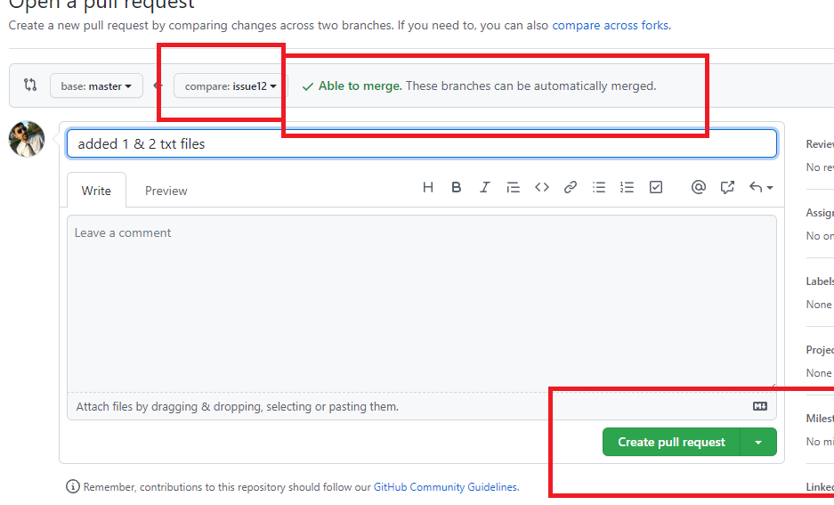

Now in the local repository you can checkout to master and use git pull

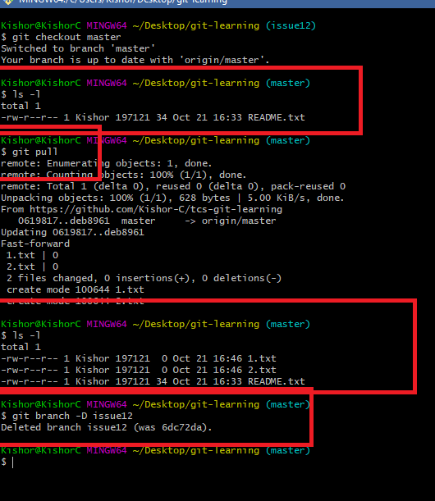

You can notice there was README.txt before git pull in master branch and after git pull there are two files 1.txt & 2.txt in master branch, the branch issue12 is of no use when the work is done hence need to delete in local machine also.

Cloning the existing repository and updating the remote repository

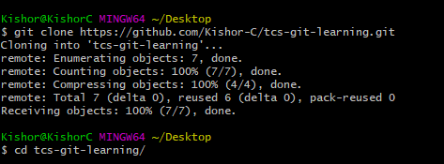

Now we can use two terminals to mimic two developers

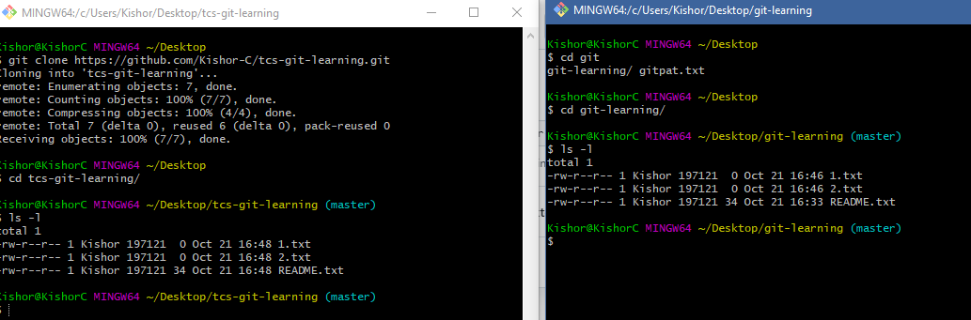

one terminal is tcs-git-learning & another is git-learning both has same repository

NOTE: Never create a repository inside another repository

What to do when conflict occurs

-Checkout to master

-Pull from remote master

-Checkout to the custom branch

-Use git merge master in the custom branch

-you will get AutoMerge not possible, hence you need to manually modify the file having conflict

-add the changes to the staging area

-commit the changes

-push the changes to the remote

-you will be able to merge the custom branch with the remote master

How to update the assignment every day in GIT

* Create a folder with a day number ex: day5, day6
* Keep the assignments of everyday in the right day wise folder

Spring Boot: It is one of the module in the spring framework which enables you to quickly create any kind of spring applications by providing auto-configuration features, spring boot doesn’t need any XML configuration file and also no need of configuring the bean dependencies required for the application, everything would be automated based on the libraries you add.

Spring Boot does all the initial setup required to develop the application, below are the important points how spring boot varies from the traditional spring framework

|  |  |
| --- | --- |
| Spring Framework in traditional approach | Spring Framework with spring boot |
| If you want to connect to the database you need to configure Datasource, SessionFactory, HibernateTemplate, TransactionManager in the XML file | No need to use XML at all, the setup required to interact the database will be autoconfigured with the help spring boot library i.e., spring boot starter data jpa |
| If you want to develop web application/REST applications you need to configure server, configure XML file to enable web application features like FrontController, View Resolver | No need of XML at all, the configurations required for web/REST is automated using spring boot library i.e., spring boot starter web |
| You need to mention component scanning in XML if you want to configure the bean with annotations | No need of XML, spring boot uses an annotation @SpringBootApplication that automates the component scanning feature |
| XML is mandatory | XML is not required, but it uses application.properties/yml file which can have application related properties, which is to write compare to XML, because it uses only key values, it doesn’t use tags like XML |
| You need to mention the compatible versions of spring libraries to make application work without any error, i.e., spring context, spring orm, spring web, spring aop and so on | In spring boot the versions of different spring libraries are always compatible by default because of parent pom library |
| We need to create the project and configure the maven dependencies manually in pom.xml | We can get a ready to run project from spring initializr website and also lot of maven dependencies are easy to configure through GUI without touching pom.xml, but you can edit pom.xml if required |

@SpringBootApplication: This takes care of autoconfiguration of the spring

Things spring boot would auto-configure based on the libraries

1. Component scanning happens automatically from the package that has @SpringBootApplication class
2. Servers, HibernateTemplate, SessionFactory, ApplicationContext are all will be ready without configuring the dependencies in XML
3. You don’t need XML at all in spring boot

Spring Boot uses a configuration file i.e., application.properties which can have application related configurations like mentioning the datasource information, Server information and so on, which is much easier to maintain compare to XML file

Spring boot has its own starter libraries to do all the auto-configuration

1. Web & REST Apis: Spring Boot Starter Web
2. JDBC: Spring Boot Data JDBC
3. ORM: Spring Boot Data JPA
4. Microserivces: Eureka Server, Eureka Client

Spring Initializr

It gives us a maven project which is a ready to run project

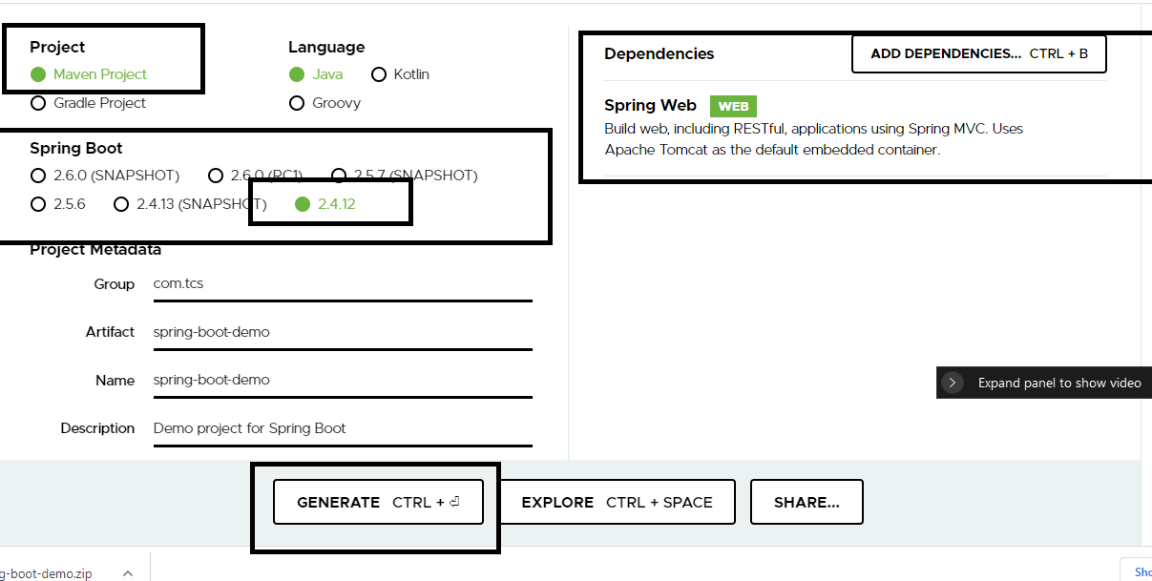

You need download the project and import the project in eclipse

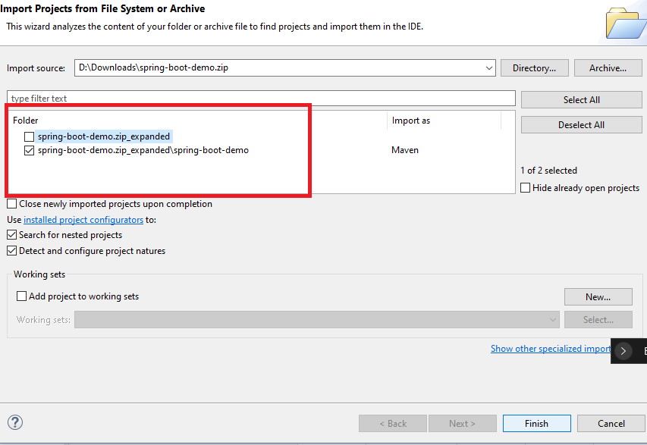

Allow eclipse to download all the dependencies.

How to create REST based applications

A class with @RestController

SpringBootDemoApplication.java

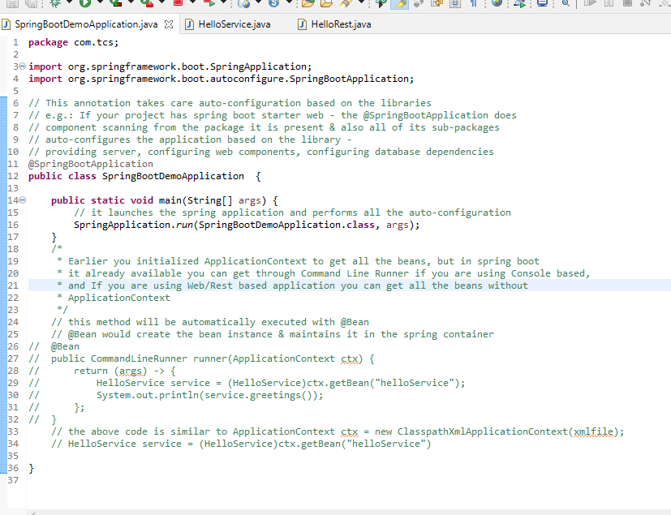

HelloService.java

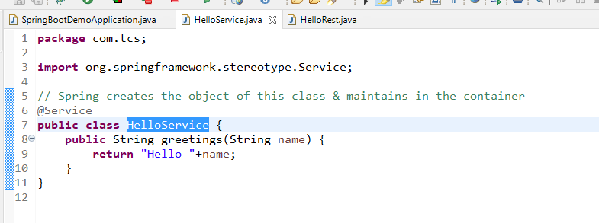

HelloRest.java

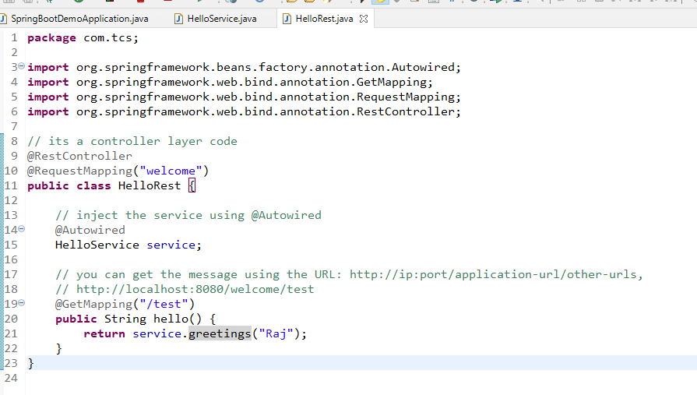

Since it is a webservice you can get the message or see the message in any device/application like browser, mobile, ATM monitor, Swiping machine, other applications written in different programming languages like Angular, React, Java, Python, C# and etc.

Seeing the message in Browser

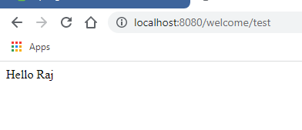

Webservice: These are online services that can be called by any type of applications written in any programming language, web services allows applications written in different languages to share the data in a common data format like XML/JSON

There are two types of Webservices

1. SOAP: It uses only XML format and it is a old type of Webservice, it can only integrate Enterprise applications i.e., Banking applications
2. REST: It uses different data formats like XML, JSON, CSV, TEXT and so on & it is used to integrate any kind of applications i.e., you can exchange the data between mobile, web, desktop, console, different devices(ATM, Swiping machine).

REST stands for Representational State Transfer, it is the more widely used webservices to exchange the data in any format like JSON/XML/TEXT/HTML/CSV and so on, but more preferred one is JSON, because it is light weight & simple to parse as it is a collection of key value pairs

ex: { “key”:value, “key”:value,….}

REST webservice uses URL and HTTP methods to create the Webservices(Producer) these URL & HTTP methods are provided to the Client (Consumer), these producer & consumer would use these end point url & http methods to exchange the data.

Some of the HTTP methods

1. POST: It means a new data is created
2. PUT: It means the data is modified
3. GET: It means the data needs to be retrieved
4. DELETE: It means the data needs to be deleted

Bank Application has a web service to return the balance to the client then, it uses GET http method same way consumer i.e., ATM / UPI applications also use GET http method to call the balance method.

In RESTful webservice intermediate data between the consumer & producer plays an important role, it means you are able to see this intermediate data in any application/testing tool then it means your services are working fine.

Postman app: It is a testing tool used to call the webservices written in any language, it can send the intermediate data in JSON/XML and also can get the intermediate data in JSON/XML

Creating webservices in Spring using Spring REST & Spring Boot

Below are the dependencies required

1. spring boot starter web
2. Dev tools(Optional): It will auto-reload the application if there’s any change, you don’t have to restart the server

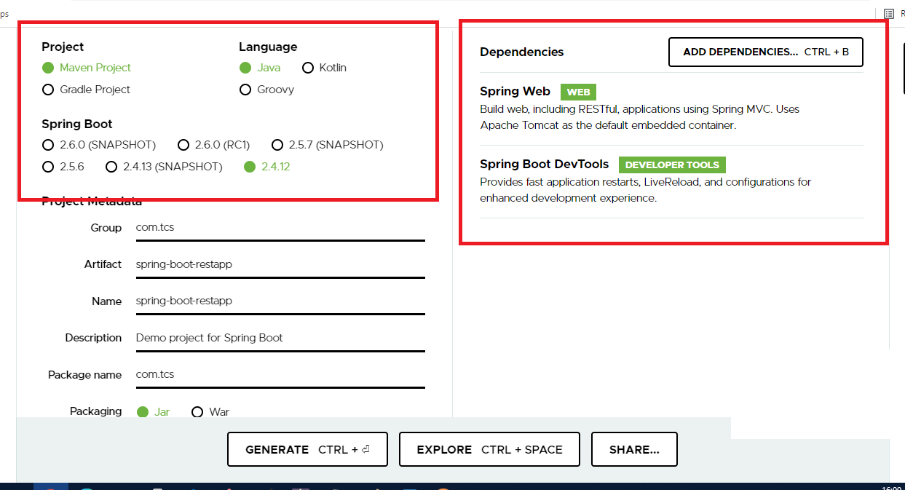

Some of the important annotations we are going to use in REST webservices

@RequestMapping: To mention the URL of the webservice

@GetMapping: To mention the HTTP GET method for a webservice

@PostMapping: To mention the HTTP POST method for a webservice

@DeleteMapping: To mention the HTTP DELETE method for a webservice

@PutMapping: To mention the HTTP PUT method for a webservice

@PathVariable: To extract the data from the URL, if the user sends the data in the URL

@RequestBody: To extract the data from the Request Body, if the user sends the content it will be present in the body of the request

SpringBootRestappApplication.java

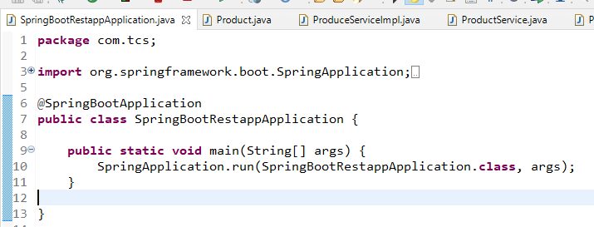

ProductService.java

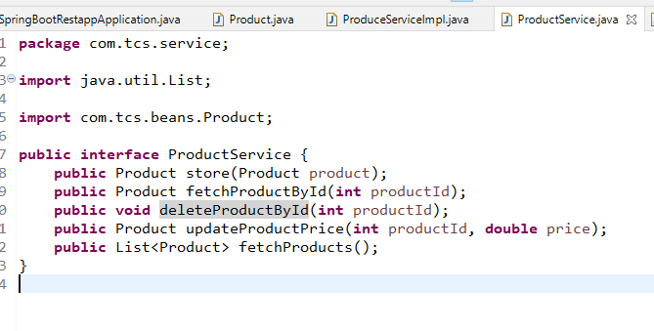

ProductServiceImpl.java

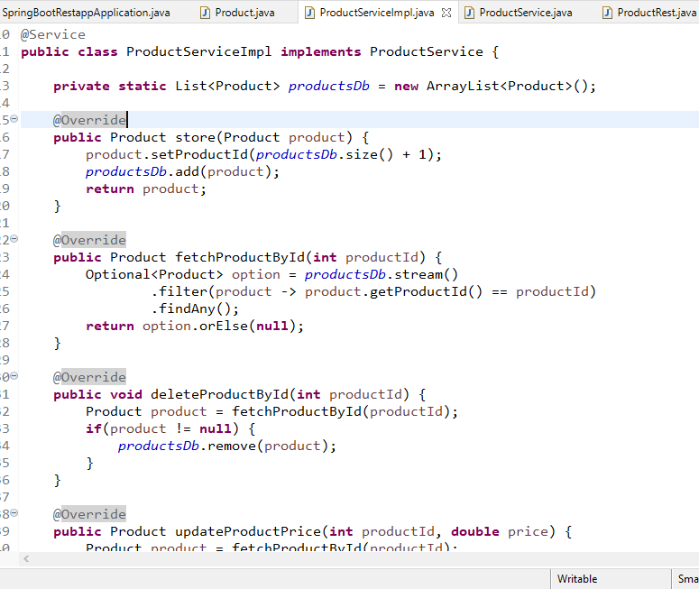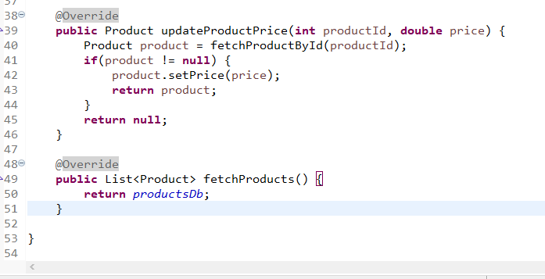

ProductRest.java

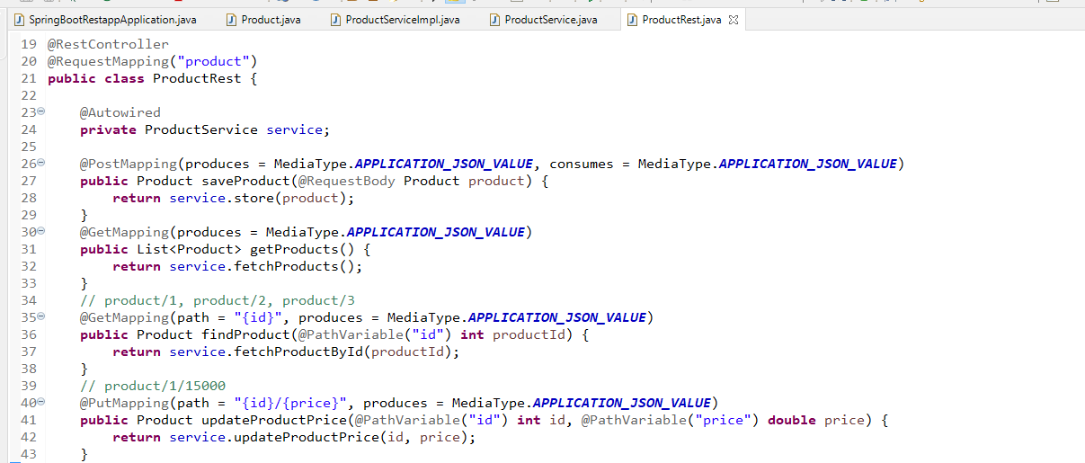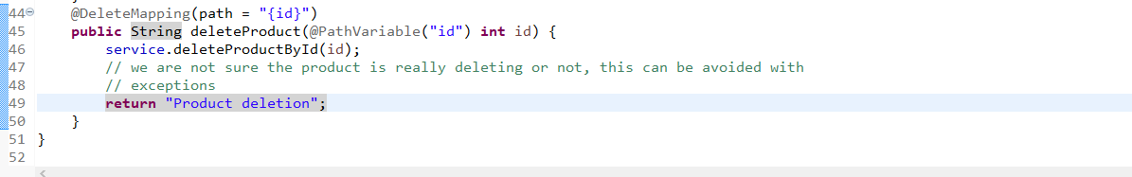

Output:

Post operation

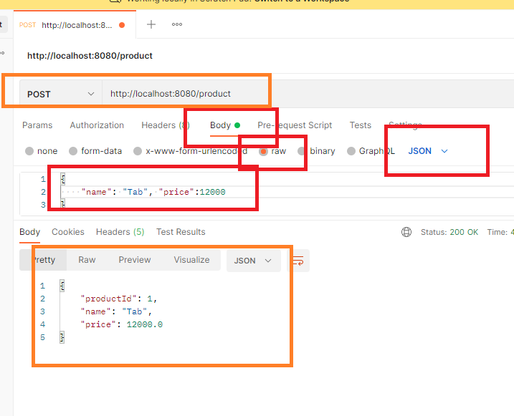

Assignment:

1. Create a checked exception with the name ProductNotFoundException and throw the exception in fetchProductById(), updateProductById(), deleteProductById()
2. Handle these exceptions in the @RestController and return a error message in JSON format

Hint: Use ResponseEntity<Object> as the return type all the webservices to return different contents from the same webservice

Input: product/100

Output 1: {“productId”:100, “name”:”Tab”, “price”:15000}

Output 2: {“message”:”sorry product with an id 100 not found”}

Spring Boot application properties

This is a configuration file which can configure properties related to the application like server port, application context path, datasource information’s, microservice configuration’s

application.properties

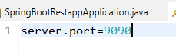

Using ResponseEntity<Object> to have different type of content in the response body

The purpose of using ResponseEntity is:

* It can provide different status code like 200, 404, 405, 401, 202, 204, based on this status code consumer can perform the action
* It can carry different content in the response body
* It allows you to customize the response.

ProductNotFoundException.java

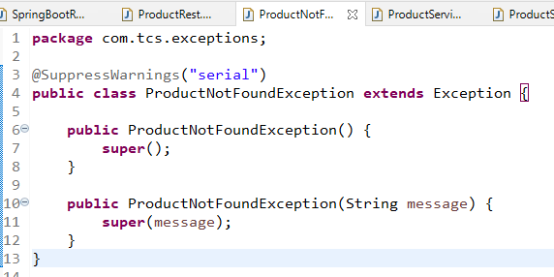

ProductService.java

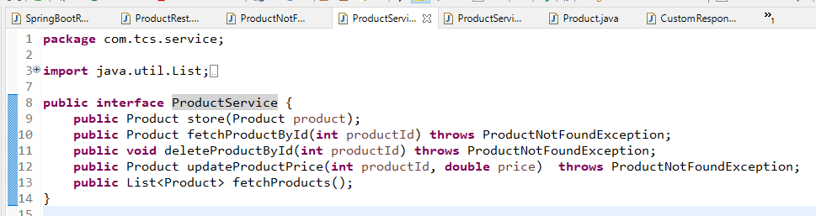

ProductServiceImpl.java

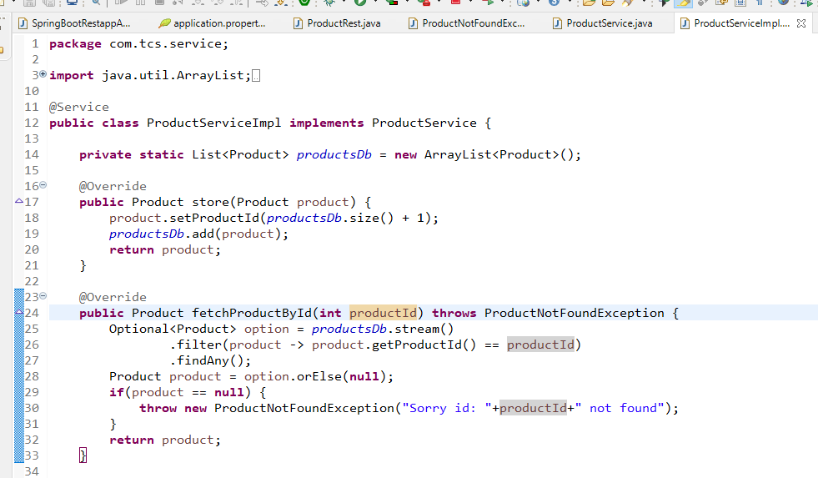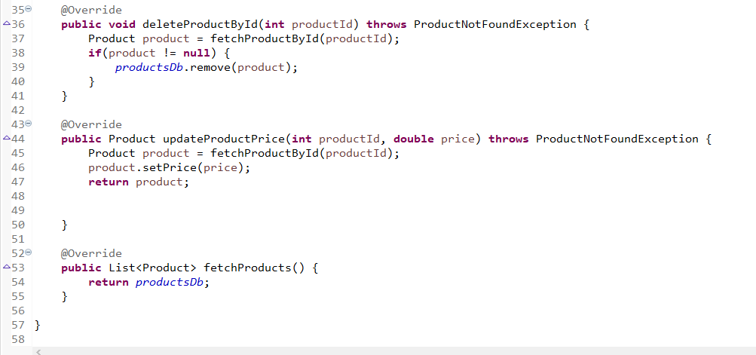

CustomResponse.java

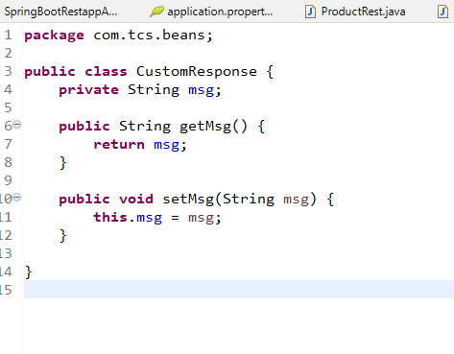

To create a response with java object so that it can be easily converted to JSON.

ProductRest.java

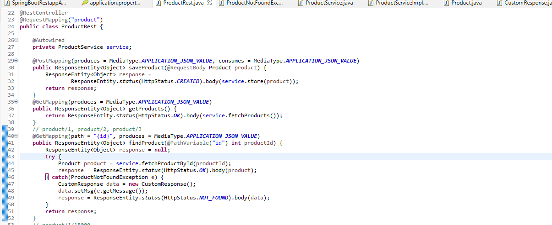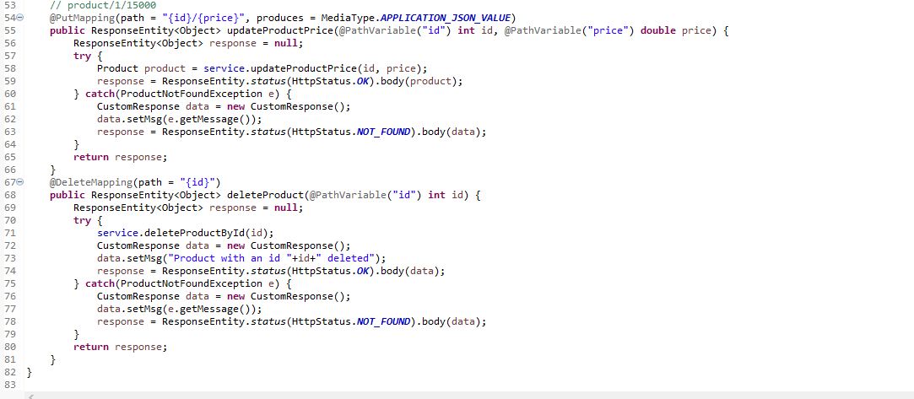

Output:

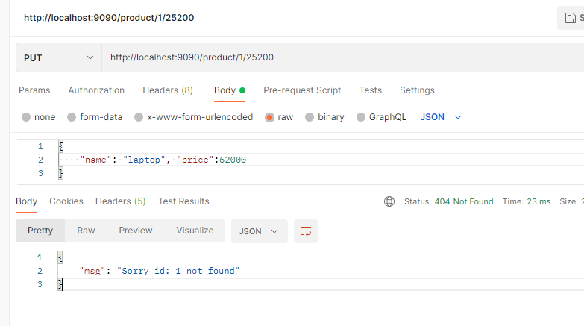

Spring Data:

It is the module which provides you some inbuilt libraries using which you can perform the database operations without writing implementation logic in the DAO layer, the spring data libraries takes care of implementing the database logics so that developer can just use the API’s provided by the spring data.

To perform operation on the database spring data provides a library called spring data jpa, using its API you can perform all the database operations, you just need to extend their API’s to map to the appropriate database table so that any operation you do would happen on the table you have mapped.

Some of the API’s from spring data jpa that you can extend are:

1. CrudRepository<T, ID>
2. JpaRepository<T, ID>
3. PagingAndSortingRepository<T, ID>

All the above API’s are the interfaces which provides methods that is already implemented by some inbuilt libraries based on the entity class you mention in ‘T’ and Primary key in ID, you just have to create a sub-interface by extending these interfaces, the methods these interface provide are:

1. CrudRepository: Provides CRUD operations
2. JpaRepository: Provides CRUD operations + Pagination & Sorting operations
3. PagingAndSortingRepository: Provides pagintation & Sorting operations

Once you use this Spring Data Jpa in the spring boot application, autoconfiguration would happen to provide implementation to these repository interfaces, in your project you must have @Entity class and data source informations in the application.properties file.

Update pom.xml to have spring boot starter data jpa library & mysqlconnector

pom.xml

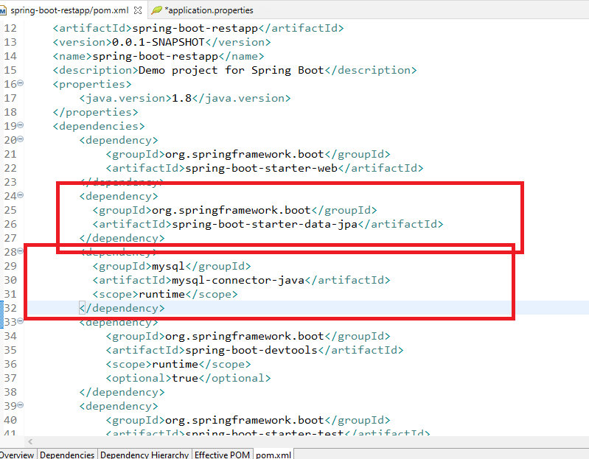

Create table product

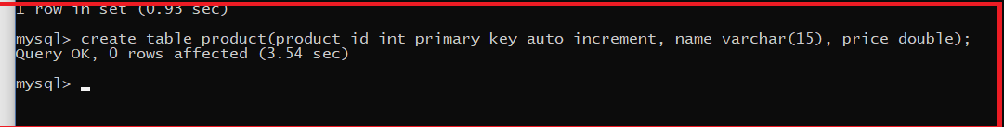

application.properties

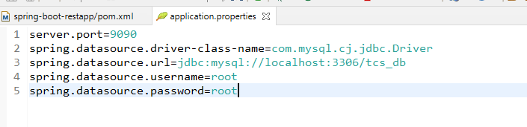

With spring boot & spring data, the advantage is you don’t have specify the dialect, entities to be configured, transaction manager, all these would be auto-configured, you just need to mention the datasource information.

Configuring the Product as entity to map to the product table

Product.java

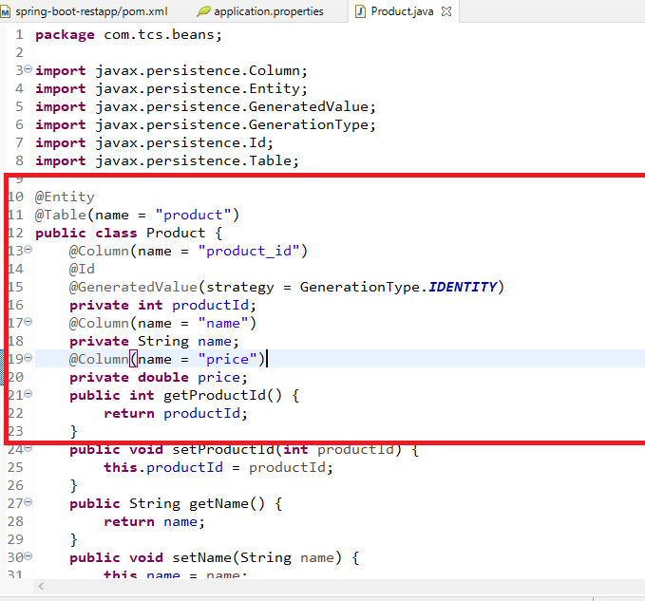

You can now use the repository interfaces like CrudRepository, JpaRepository to call the methods present in it, for that you need to create a sub-interface that extends the repository interfaces.

If you extend the Repository interfaces then all kinds of database operations you can do, if in case you want to have a customized operation, you can write methods in the interface an on top of it you can write JPQL

ex:

interface EmpRepo extends JpaRepository<Employee, Integer> {   
 @Query(“select e from Employee e”)  
 public List<Employee> getAll();  
}

ProductRepository.java

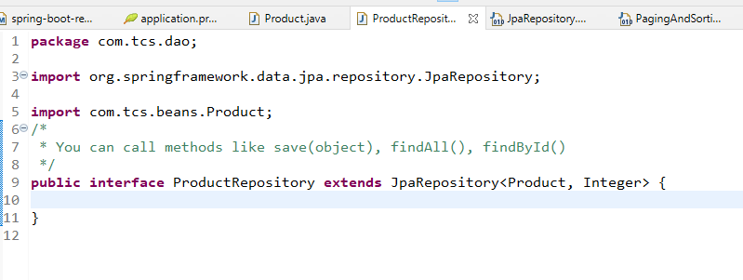

Note: Spring boot will maintain an instance that implements ProductRepository to perform operation on Product table, you don’t have to create any implementations, you need to just use @Autowired on ProductRepository in the Service Layer

Since we already have ServiceImpl with temporary List, we can change it accordingly so that it can use ProductRepository.

Some of the CRUD methods available in JpaRepository are

S save(S s): Stores/Update the entity

Optional<T> findById(ID id): Retrieves the entity if Id is found else it will have null

List<T> findAll(): Retrieve all the entities & returns the List

void deleteById(ID id): Deletes the entity using the id

ProductServiceImpl.java

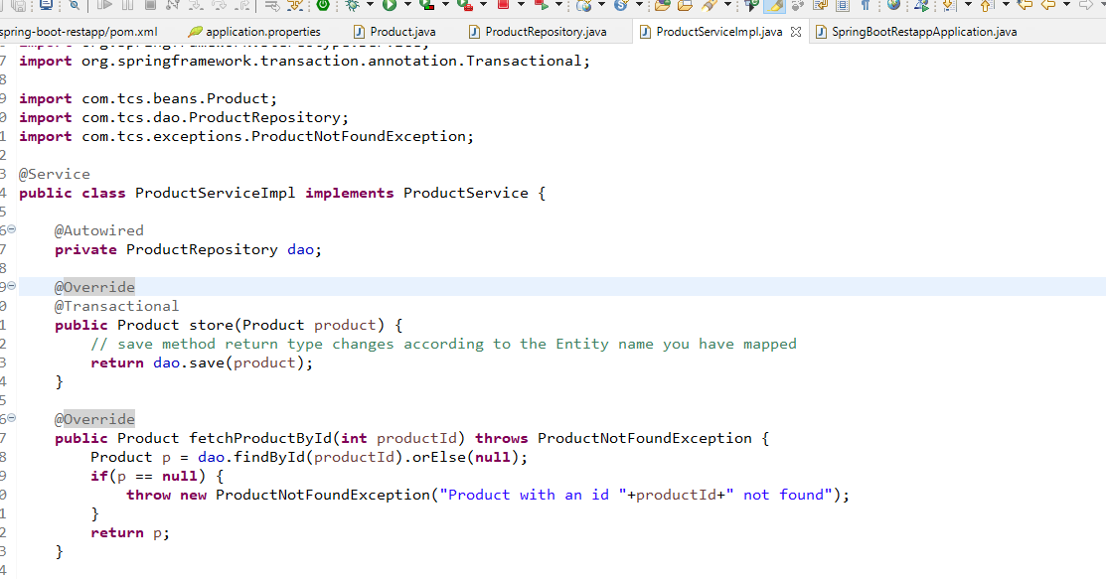

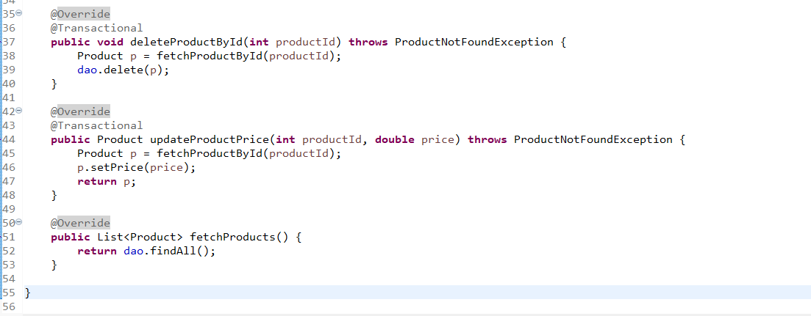

No changes in the @RestController

You can see the same output in the postman

Assignment on Transaction

1. Create an entity with the name Account which will have properties like accountNumber, username, password, dateOfBirth, balance
2. You should able to perform some CRUD operations on the Account entity like register, transfer, update
3. Create account for various users which will auto-generate the account number, a user must able to transfer the amount from his/her account to another account using accountNumber and amount as a parameter, if the balance is not sufficient user must able to InsufficientBalance error
4. User must also able to view the account details like accountNumber, username, dateOfBirth and balance
5. User must able to update the password

Considering the above scenario create a RESTful webservice with service & DAO with appropriate interface & methods.

Scenario1: User must register by providing username, password, dob & balance

Scenario2: User must able to transfer the amount to another account using the account number and if the balance is insufficient show the InsufficientBalanceException

Scenario3: User must able to update the password

Note: All the response must be in JSON format, use appropriate HTTP status code related to success/error responses, ex: 200 for success 404 for errors

Properties file or YAML files

Spring boot uses property files with .properties or .yml extension, the difference is yml uses indentation between the parent & sub properties however the properties uses . between the parent & sub properties, yml avoids repeating of properties.

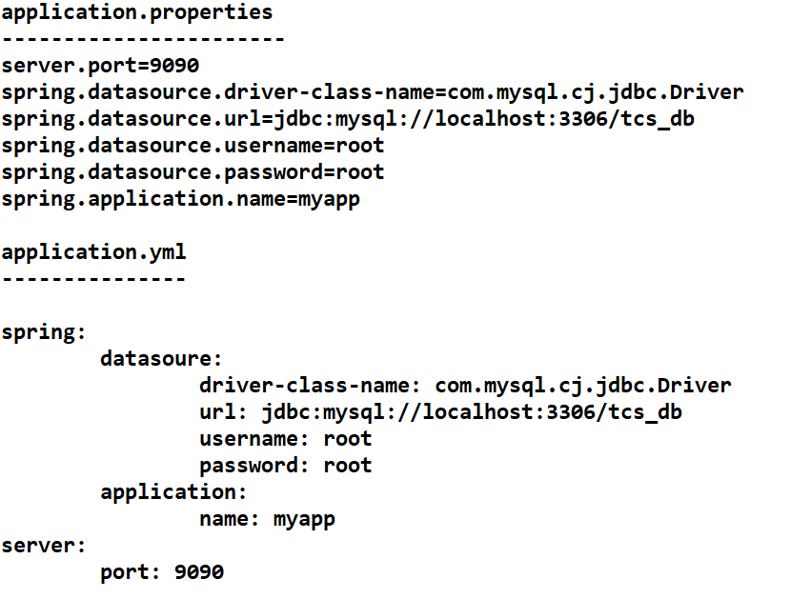

application.yml

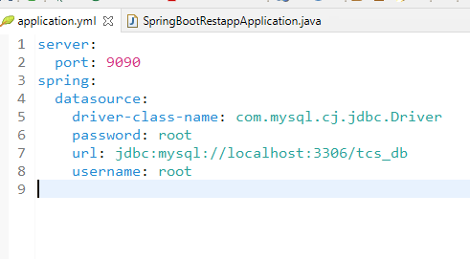

Joining the entities using some JPA annotations like

@OneToOne

@OneToMany

@ManyToOne

@ManyToMany

Requirement: For a particular profile you can have multiple contacts. We need two tables with Profile & Contact

Profile will have profileId(PK), name, dob, phone and

Contact will have contactId(PK), contactName, mobileNo and profileId(FK)

Create two tables as below:

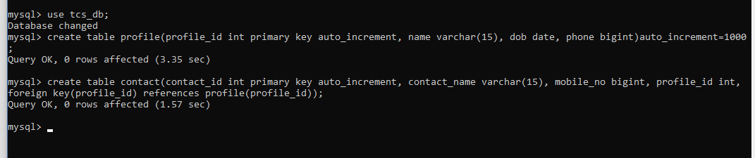

Store some dummy records in profile & contact

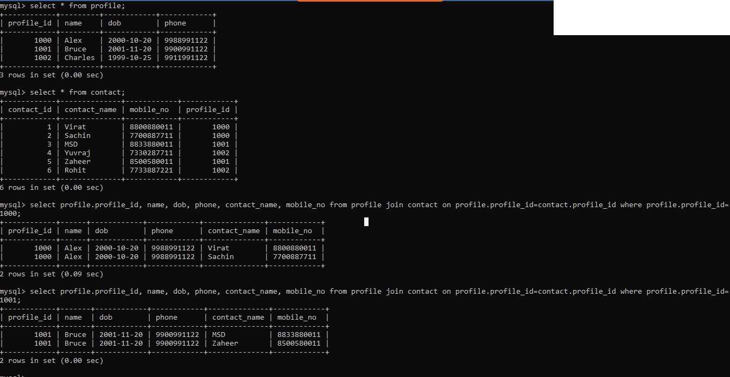

Above results are generated from the join query, but in JPA we don’t have to write join queries we have annotations that generates the join query, we need to use them in the entities.

Requirement:

Based on a profile we need to get multiple contacts, so we need a List<Contact> to store multiple contacts & add the List<Contact> in the Profile

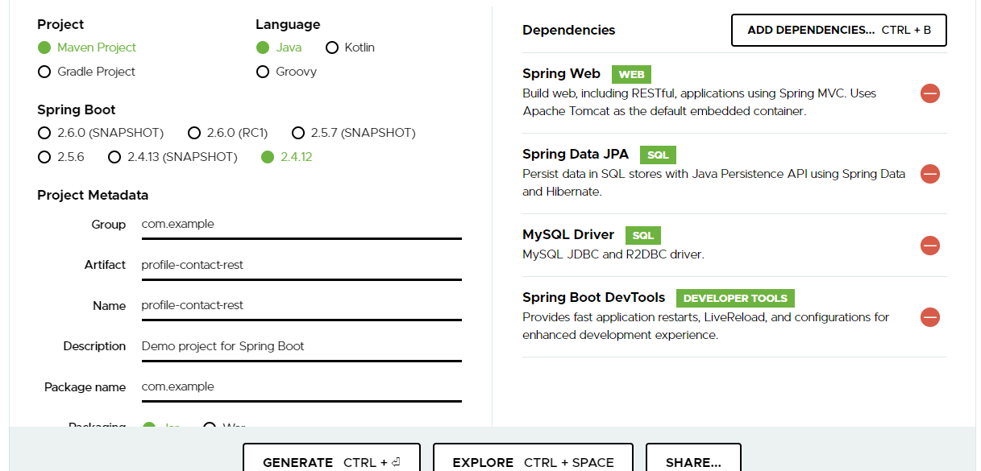

application.yml

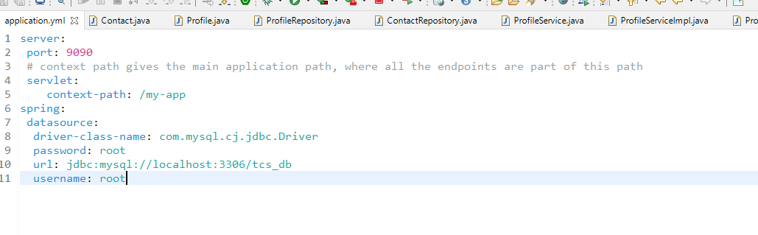

Note: URL could be now http://ip:9090/my-app/path/subpath

Contact.java

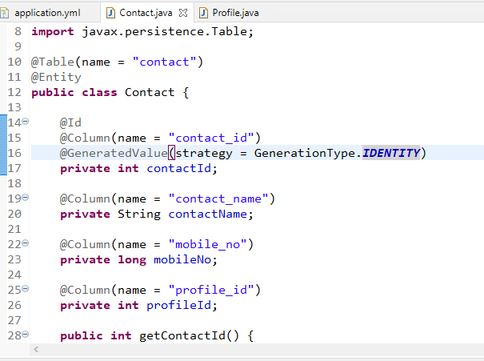

Profile.java

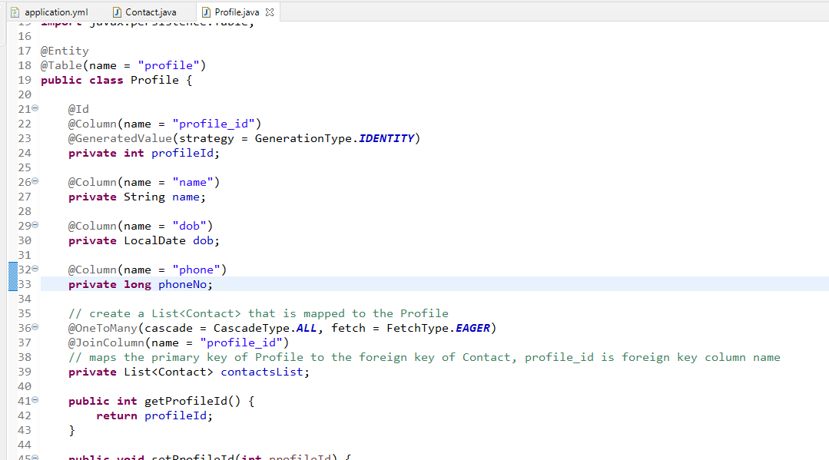

You need two repositories to perform CRUD operations, as we have two entities.

ProfileRepository.java

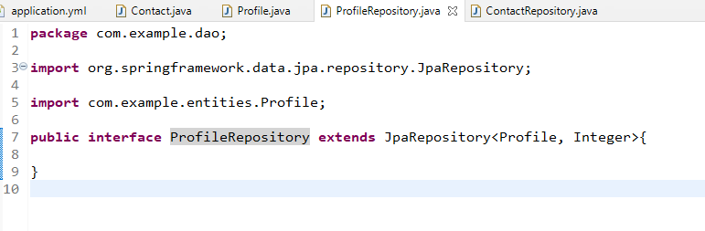

ContactRepository.java

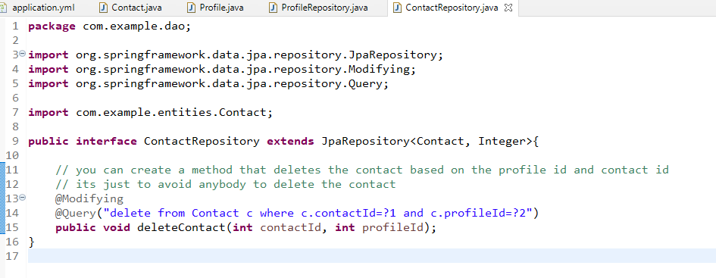

Note: Though you have a delete operation based on the primary key i.e., contact_id, you need to know the foreign key of the contact to delete, just to ensure only the particular profile having that contact can delete the contact from the profile.

ProfileService.java

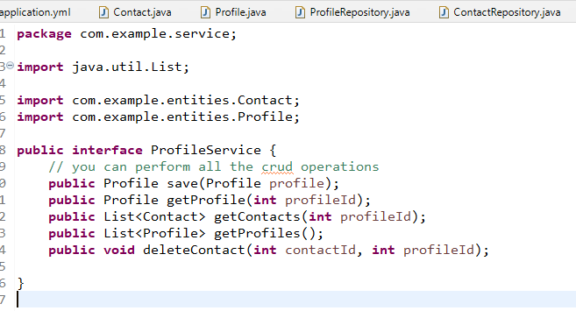

ProfileServiceImpl.java

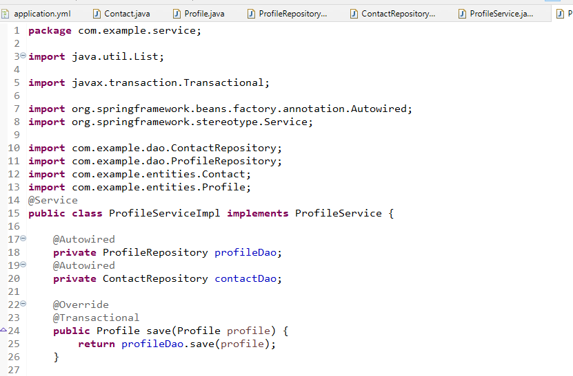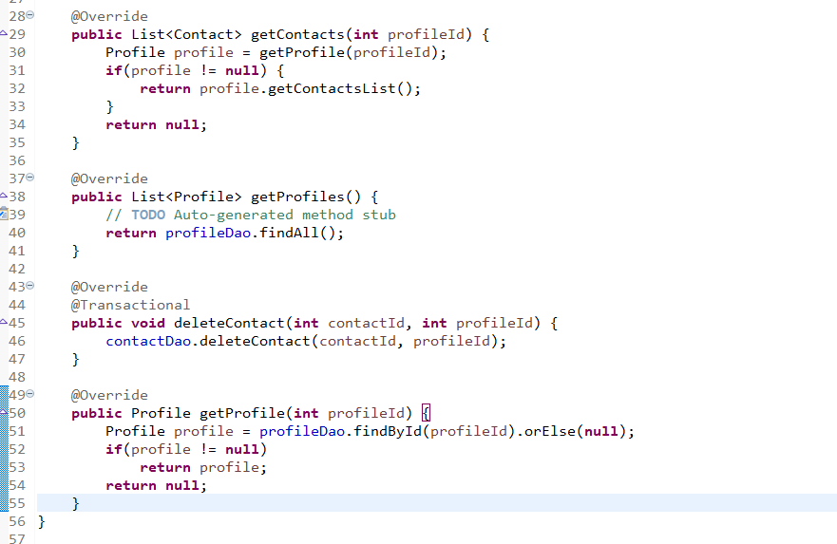

ProfileRestApi.java

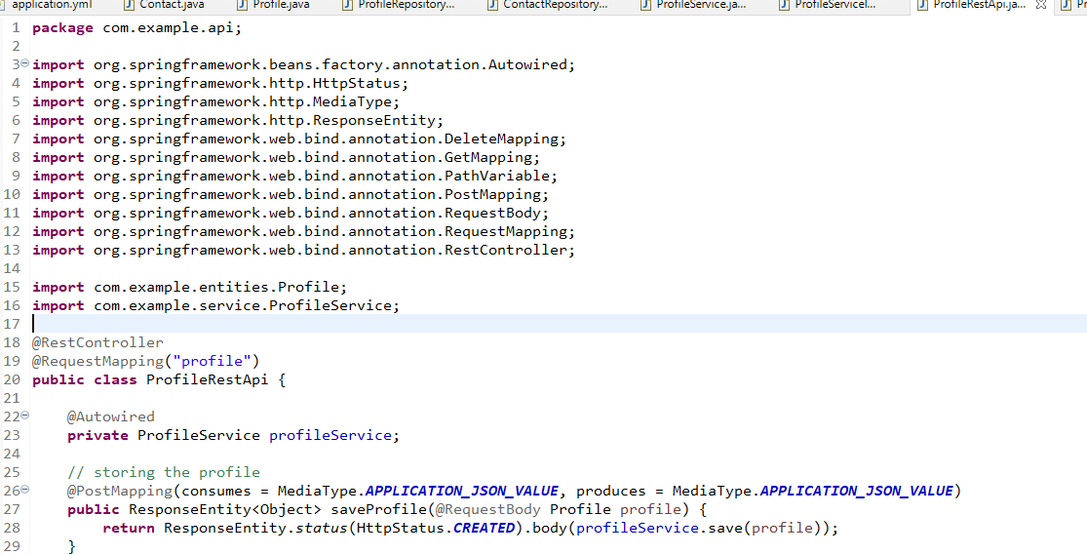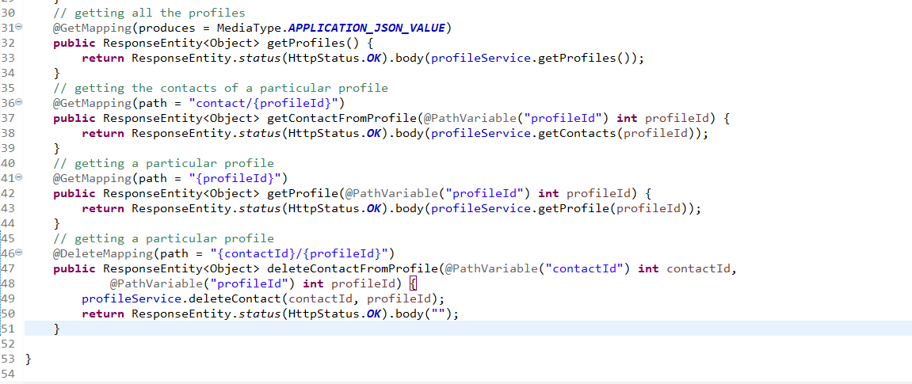

Output:

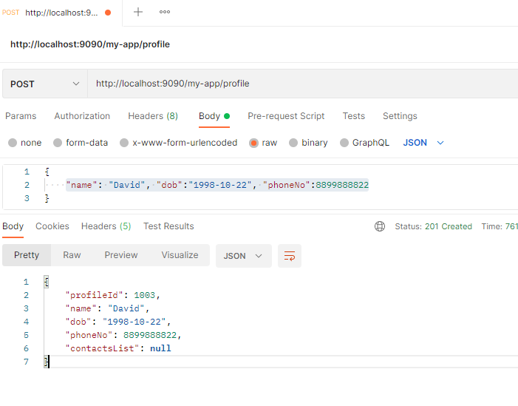

Assignment:

1. Create a method addContact(int profileId, Contact contact) in the ProfileSerivce, so that you can store the contact for a particular profile, test this form the Postman
2. Create Some checked exceptions to show error response in JSON format

Microservice:

These are small independent services that can be independently develop, test, build and deploy, it resolves lot of issues with the traditional approach of application development i.e., Monolithic architecture.

Every microservice will have their own database which are independent from other microservices

Benefits of using Microservice architecture

1. A single application can be decomposed into multiple services and it can developed & deployed independently
2. It creates a loosely coupled applications so that testing would be easier i.e., you need to test only the module which you have changed as each module goes to independent servers
3. You can scale only the particular service you want, instead of scaling the entire application, scaling only part of the application is better
4. If any module goes down it affects only the module which is down not to other modules as they are deployed in different environment
5. Easy to maintain the application as its not an entire application needs to maintained
6. Encourages using different programming languages, advantage is better service can use better languages. ex: UI related code can be implemented in Javascript instead of using Java, Datascience/Machine learning related code can be implemented in Python, Transaction related code can be implemented with Java.

Spring Microservices

* It is a module which is used to create microservices using spring technologies, spring provides two projects to quickly develop microservices
  + Spring Boot: Quickly creates spring applications & provides auto-configuration features
  + Spring Cloud: Provides all the design patterns & tools required to develop microservices

Features required to implement Microservices

1. Service Discovery: Registry to register & locate the microservices
2. Microservices: Services that will have business logics
3. Externalized Configuration: Distributed configure for multiple microservices
4. Load Balancer: Equally distribute the load when there are multiple instances of same microservice
5. Circuit Breaker: To trip the communication to avoid the cascading fail overs when any microservice is down/slow
6. API gateway: Common door for all the microservices to use single endpoint url & also to achieve reverse proxy
7. Security: Using OAuth2 & JWT you can secure the microservices

Note: Spring cloud is the module which provides you all the above features and design patterns with simple annotations and configurations.

Spring Microservices depends on two project/modules Spring Boot & Spring Cloud, & these modules should always be compatible, hence you need to refer the spring web site to check the release trains of spring boot & spring cloud

ex: spring boot 2.2.x might be compatible with Hoxton.SRX

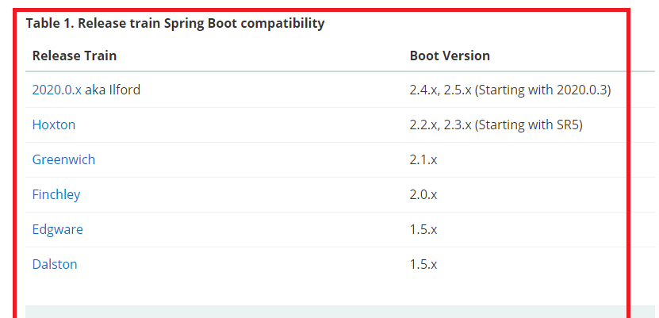

You need to manually change the spring boot & spring cloud version if in case spring initialzr doesn’t show the right compatible version’s of both the projects, if you miss configuring it you would end up in errors though your code is correct.

Pre-requisites to understand spring microservices

1. Java 8
2. Spring Boot
3. Spring REST

Microservice uses REST based architecture which is more widely used architecture compare to SOA architecture (Old architecture)

SOA: Service Oriented Architecture, it uses 3 components when they want to communicate

1. Service Producer
2. Service Consumer
3. Service Broker

Drawbacks of SOA is it communicates only via XML, it can only integrate enterprise applications, the consumer needs the interface to know the producer operations.

REST:

Here REST uses client server way of communicating. The consumer doesn’t need interface it needs the URL & http method of the producer.

REST can represent data in any format like XML/JSON/TEXT/CSV, but more widely used is JSON because it is easy to parse & it is light weight

REST vs Microservice

Microservice:

It uses REST based architecture along with that it uses a registry called Service discovery and other important features of microservices like circuit breaker, load balancer, distributed configuration and so on.

Service Discovery:

It is a naming directory to store all the microservices address and also it can identify the services which are not available, it helps microservices to locate other microservices.

Once Microservice registers in the service discovery it sends heart beans every 30s to the service discovery to say it is active, if in case any of the microservice is down then it doesn’t send heart beans with 30s then service discovery wait for 2 more chances to invalidate the microservice from its registry.

How to create service discovery in spring

In spring microservices the spring cloud provides you an Eureka Server which acts like a service discovery, you can create service discovery using a simple annotation @EnableEurekaServer

Dependency required

Eureka Server

Note: Create this in a separate project & ensure spring boot and spring cloud versions are compatible

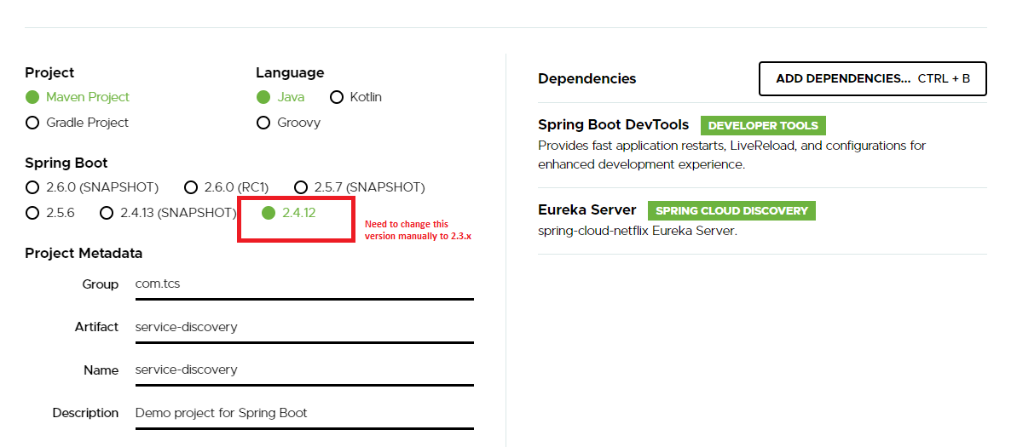

Change pom.xml to ensure spring boot and spring cloud versions are compatible

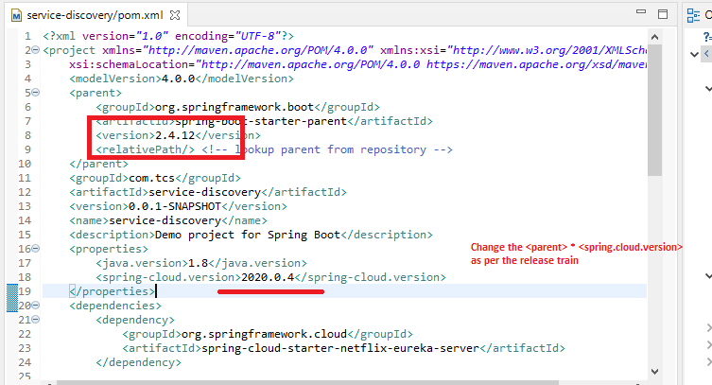

After the update

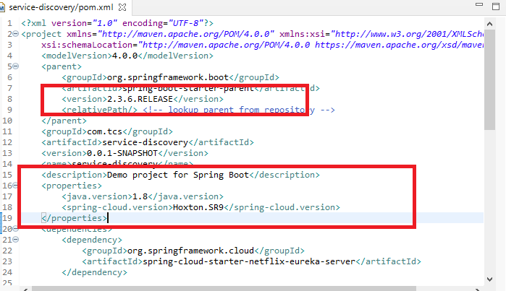

Writing @EnableEurekaServer

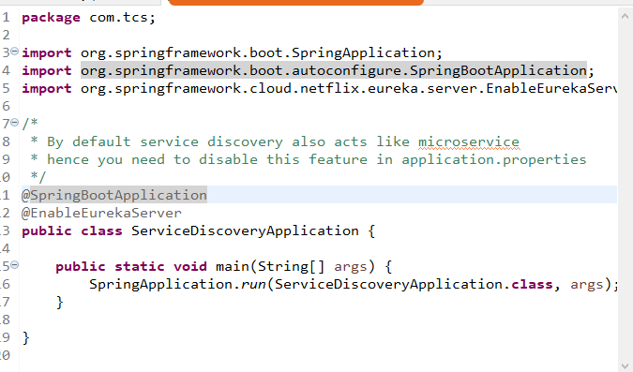

Configuring application.properties to disable service discovery to register itself as a microservice & fetching from the service discovery

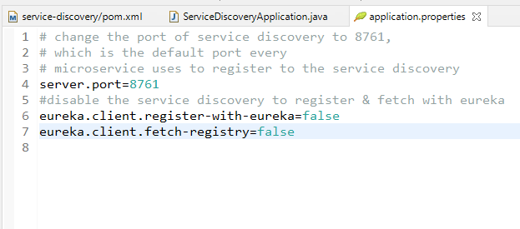

Now you can launch spring application and you can see the dashboard of Eureka which shows all the microservices, but right now there wouldn’t be any microservice

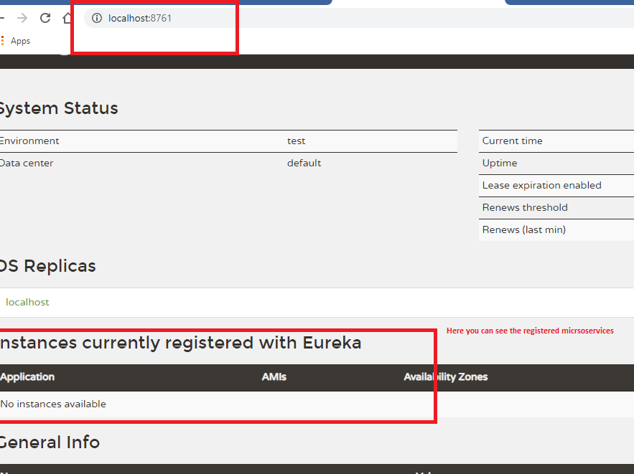

Creating our first microservice and registering it in the service discovery

A microservice is a small service which is a REST based service which will have endpoint-url, if you want this service to act as a microservice you need to register in the service discovery.

How to register into the service discovery

@EnableEurekaClient is the annotation that registers your microservice into the service discovery.

The annotation is part of Eureka Client library.

Create a separate project with the following dependencies

1. Eureka Client (To register as a microservice)
2. Web (To create REST webservices)
3. Devtools (Optional)
4. Other libraries you need based on the requirement like Spring Data JPA, MySQL Connector, Security

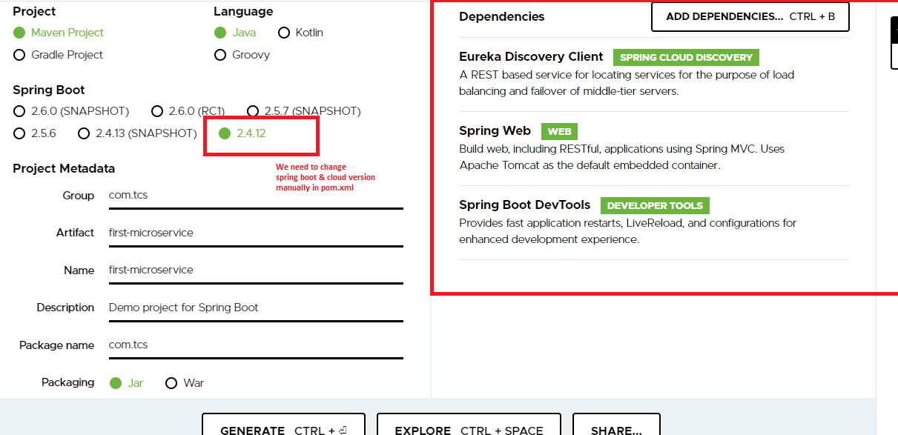

Change pom.xml accordingly

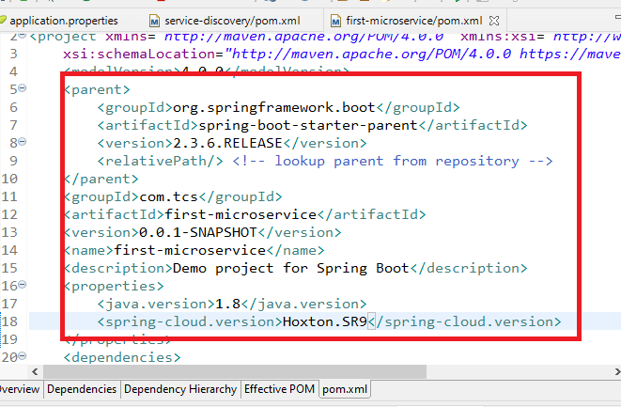

You have a library of Eureka Client which will automatically registers into the service discovery by locating the service discovery in 8761 and it fetches the information from service discovery by default.

Configuration your application with @EnableEurekaClient

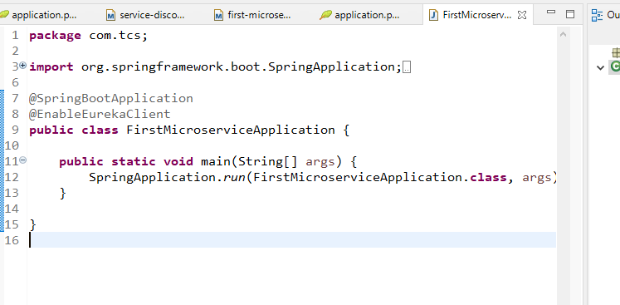

Create a simple webservice with an endpoint and http methods

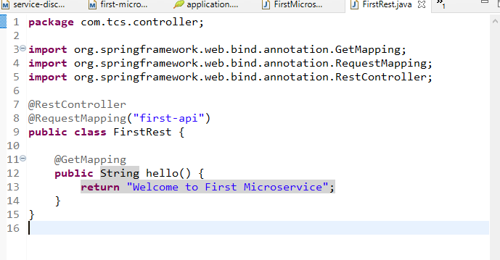

You can always access this web service using the ip address & port of the application, but when it is registered as a microservice it will have a logical name that is used by other microservices to communicate

Note: Logical Name should not be changed though the physical address of the microservice changes.

Note: By default microservices will not have any logical name, you need to mention it the property file

bootstrap.properties/yml

It is the configuration file that is loaded before the application.properties, you want any configuration to be loaded before the application bootstrap you can have them in bootstrap.properties, ex: GIT url, logical name of the microservice, security key

bootstrap.yml

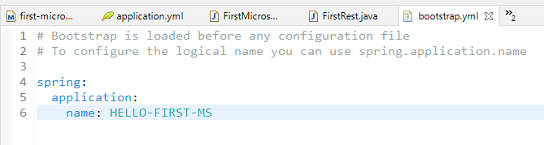

application.yml

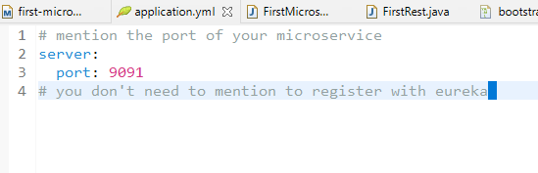

Now you can launch your application which will register in eureka server

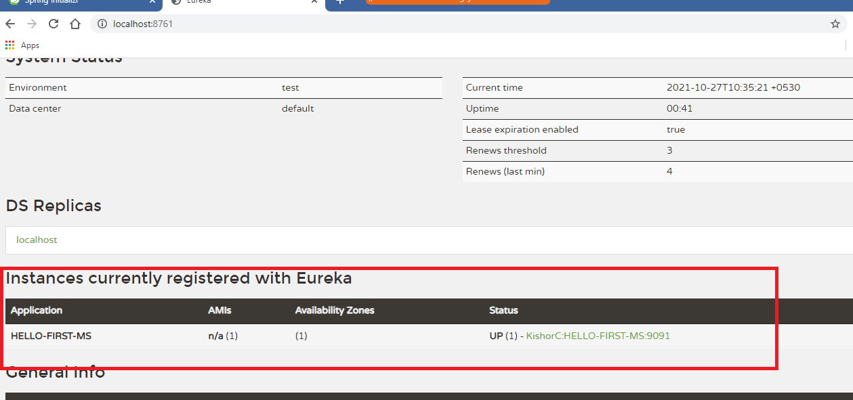

Exercise: Create another microservice i.e., HELLO-SECOND-MS and register in the eureka server & observe the instance in the Eureka Dashboard

Communication between the microservices

A microservice can call another microservice to exchange the data, but it must use the logical name of the microservice to communicate not the physical address.

How to communicate with the microservice

Since microservices are REST based services you have to use the API which to call the rest services, in Spring Boot we have a RestTemplate that can be used to call the webservice providing the physical address, however you can use logical name also with RestTemplate but it must be Ribbon aware RestTemplate which should use LoadBalancer who takes care of mapping the logical name to the appropriate physical address.

In Spring Microservice you use @LoadBalanced annotation on RestTemplate, which is a Ribbon aware RestTemplate.

Ribbon Aware: It uses the client side load balancer to communicate with other microservices using the logical name, it will have the idea about how many instances of the same microservices are running, based on the number of instances the client side load balancer distributes the load across the instances.

Let us assume first microservice as banking service which returns some amount through Transaction object & we will add that amount in second microservice which is like a wallet service.

Add Transaction.java in both the service because both the service represent the transaction data

Note: Name the class can be different however the properties should match to the JSON structure, i.e., First Microservice JSON structure is used by Second Microservice through a class that has properties matching to JSON

Transaction.java in First Microservice

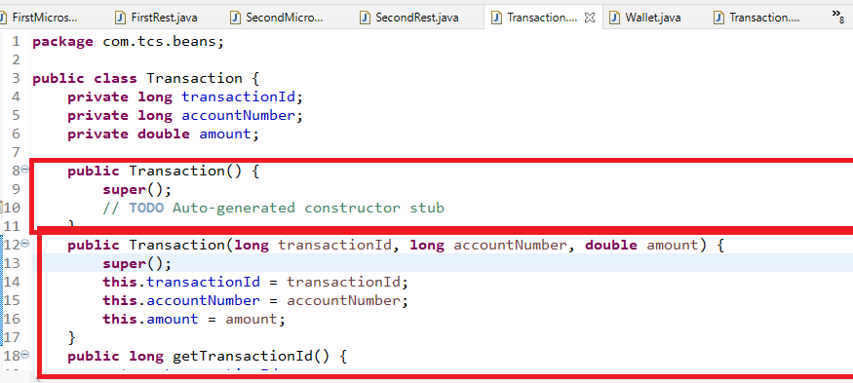

Create a webservice in First Microservice to return Transaction in JSON format

FirstRest.java

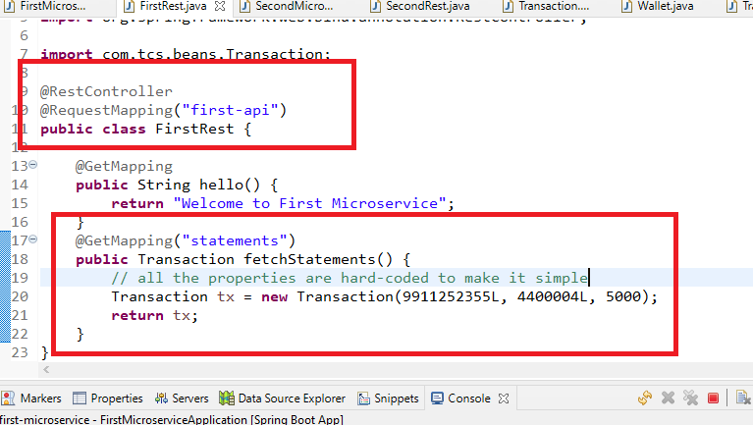

We need to call the First Microservice from Second Microservice, so we need to use RestTemplate with @LoadBalanced

Create RestTemplate object in second microservice

SecondMicroserviceApplication.java

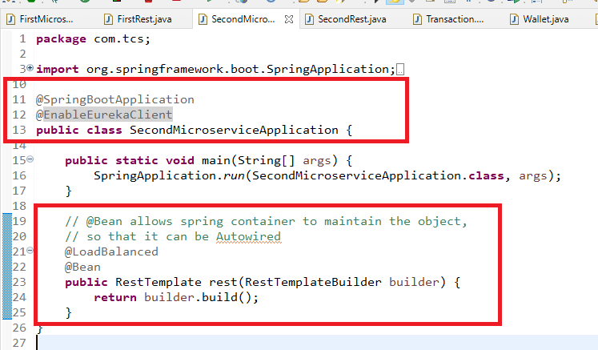

Create Transaction.java in Second Microservice or it can have any other names but it must have properties that matches to the JSON data of First Microservice



Create Wallet.java in Second Microservice with some hard code balance

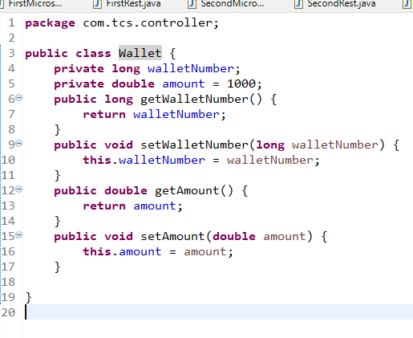

Calling First Microservice from Second Microservice via RestTemplate and using Transaction data of first microservice in the wallet object of second microservice

SecondRest.java

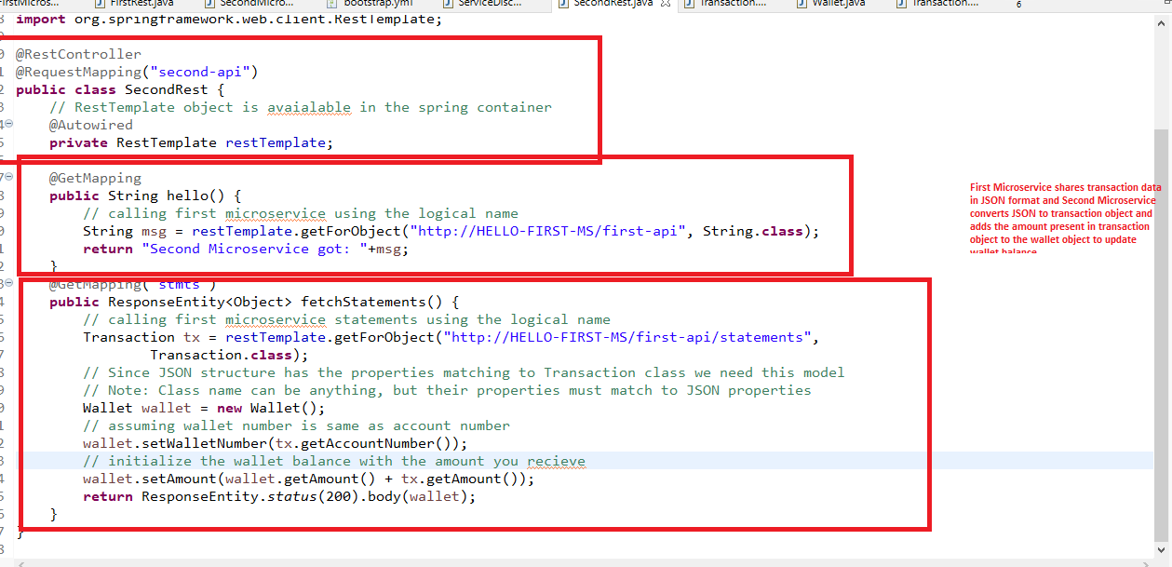

Now if you call stmts of second microservice in postman using the physical address you can see the wallet amount updated

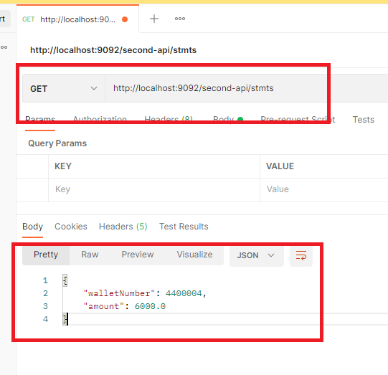

How to run multiple instances of same microservice

You can create an executable jar and run using command line, through command line also you can run the microservices application and change the port number using some command line options:

ex: java -jar app-name.jar --server.port=8082.

How to create an executable jar in eclipse

Project -> Run -> Maven build -> Goals = package

The above steps creates the executable jar in target folder.

Build jars for first microservice & run using java -jar command, when you run these jars they take port mentioned in application.properties, which you can override using --server.port option

Executing first microservice jar in port 9095 & 9096 in separate command prompts.

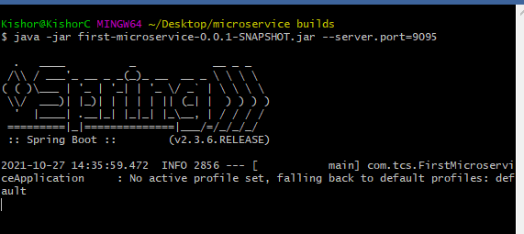

The above command prompt launches first microservice in port 9095

Another instance you run in eclipse.

Now you can check the eureka dashboard to see 2 instances of first microservice & 1 instance of second microservice.

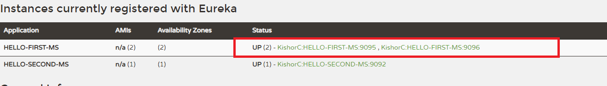

Another way of communicating between the micrsoervices

Feign Client: It allows you to call the microservices without using RestTemplate & LoadBalanced API’s, it is reusable because Feign Clients are written with the interfaces which will have the methods to communicate with the microservices, you don’t have to implement the interface, you just need an interface with @FiegnClient that will have the end-point address of the microservices

Library is

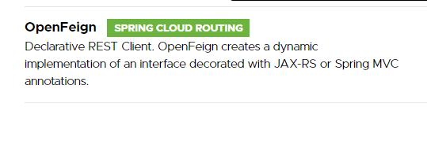

Add the dependency in the second microservice to communicate with the first microservice

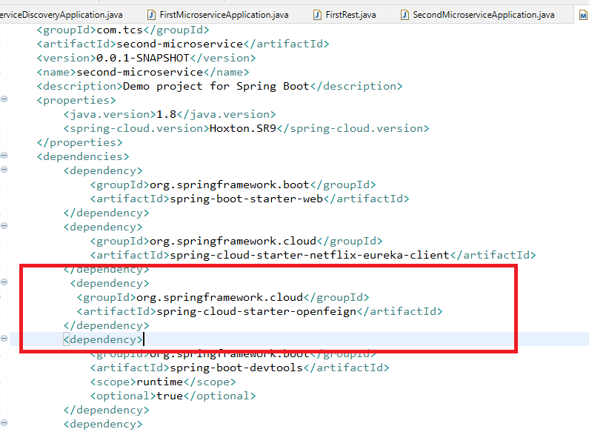

Now you can create an interface with @FiengClients that will have the microservice end point address, this interface you don’t have to implement, but you need to use @EnableFiegnClient in your application so that it can use the feign client features like load balancer internally.

Configuring the application with @EnableFiegnClients

SecondMicroserviceApplication.java

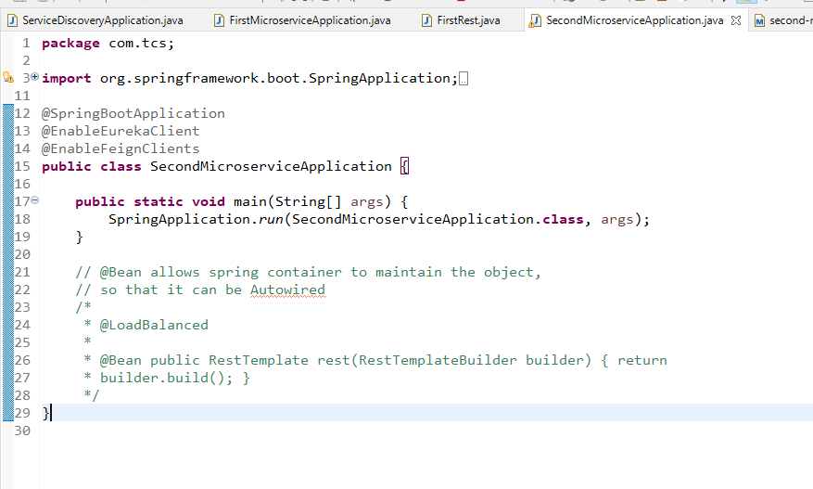

You can comment the RestTemplate, as feign client internally uses the RestTemplate & LoadBalancer.

You need to create an interface that will have operations which can communicate with other microservices.

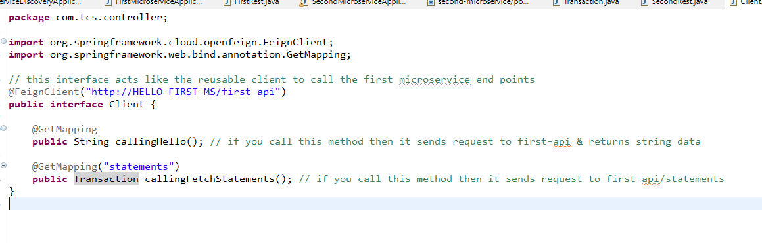Now you can just autowire the interface reference and call the methods present in it.

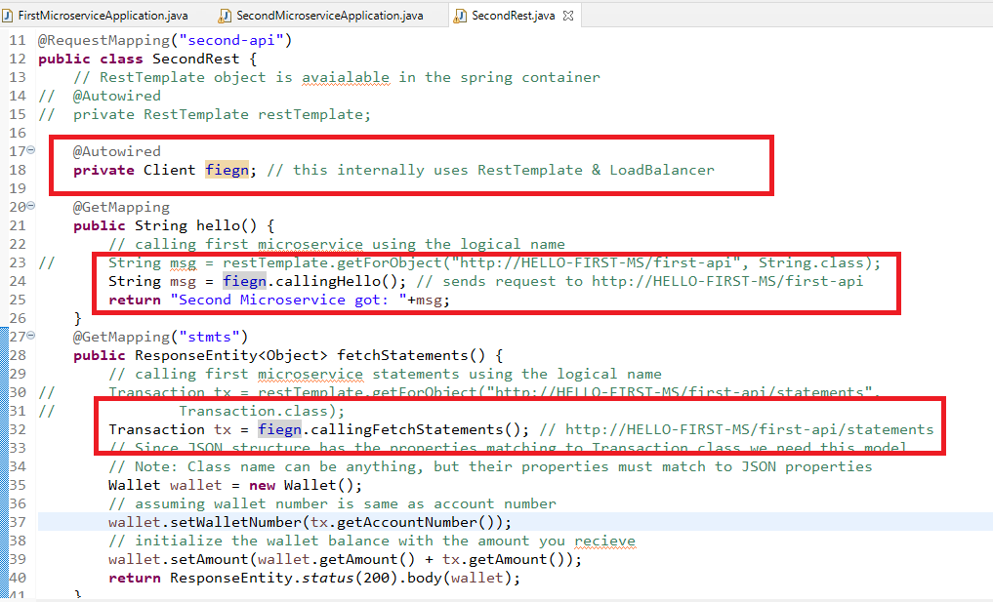

Output:

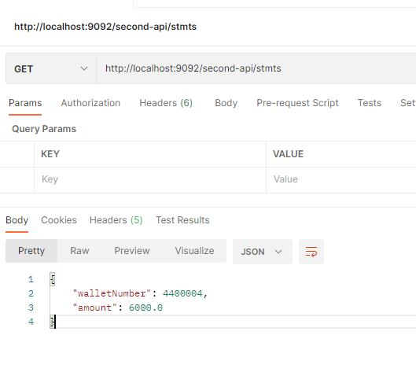

Distributed Cloud Configuration

You can have your application configuration distributed by using some centralized location like GIT, so that these configurations can be pulled to run your application based on the environment, you don’t have to manually configure these configurations when the application moves to different deployment pipeline.

Suppose your application needs to pull different configuration in different environment then you can have these configuration files in the cloud and pull the configuration for a particular profile/environment.

ex: assume you have four different configuration files

1. app-dev.yml
2. app-test.yml
3. app-prod.yml
4. app.yml

Now your application can pull app.yml by default, app-dev if your profile is dev, app-test if your profile is test, app-prod if your profile is prod, but if the profile is not mentioned then the application can use app.yml.

These configurations are distributed, it can be used by multiple microservices.

How does the spring cloud configuration work

Spring cloud configuration uses an application/program which is known as cloud config server, which knows the location of the external configuration i.e., cloud configuration, it can pull all the configuration files from the cloud and provide it to the microserivces or any other applications.

Config Server: A main application that connects to the external cloud configuration location.

Config Client: An application that connects to the config server to get the configuration it needs, a config client can be service discovery, microservice, api gateway and so on.

We need minimum 2 projects

1. Project that acts like Configuration Server
2. Configuration Client Project that connects to Configuration Server

Dependency Required

1. Configuration Server
   1. Config Server
   2. Dev tools
2. Configuration Client
   1. Config Client
   2. Web
   3. Actuator (Monitor the application in production)
   4. Dev tools
   5. Eureka Client (If required)

Configuration Server Project

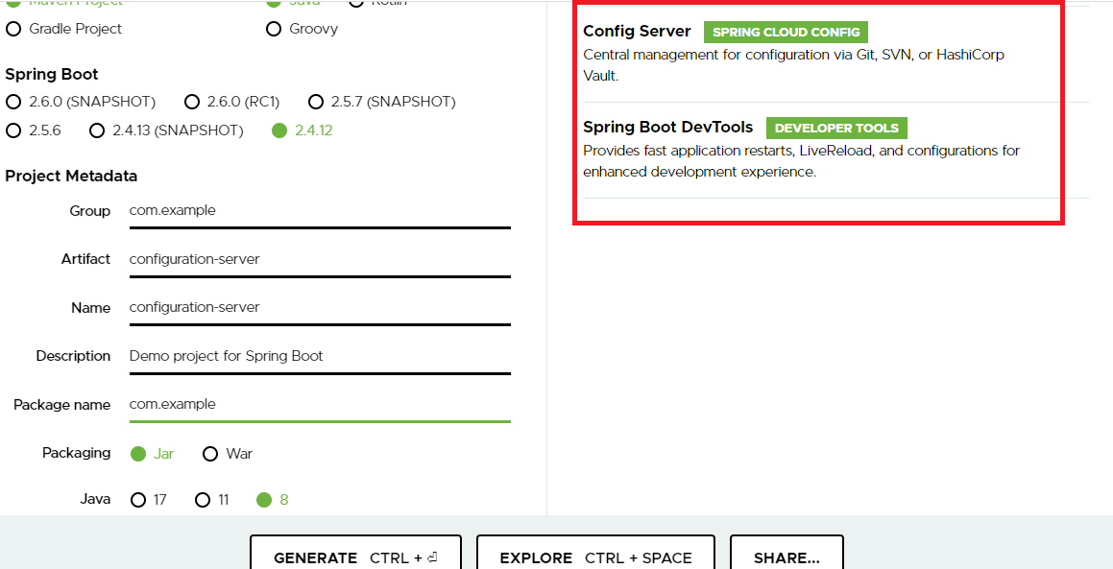

Note: Change the spring boot & spring cloud version to be compatible.

Since config serve needs to know the location of the centralized configuration files, you need to provide the URL of the cloud i.e., git url, currently we have 4 files in the below repository.

<https://github.com/Kishor-C/config-dist.git>

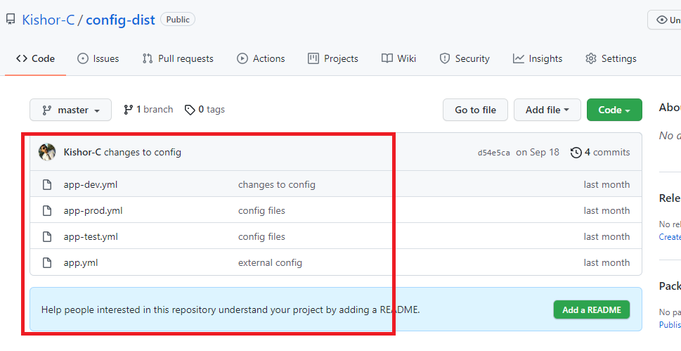

We need to use <https://github.com/Kishor-C/config-dist.git> URL to connect to the repository in the config server.

We also need to use @EnableConfigServer that can take care of connecting to the cloud and pulling the configuration to the appropriate clients

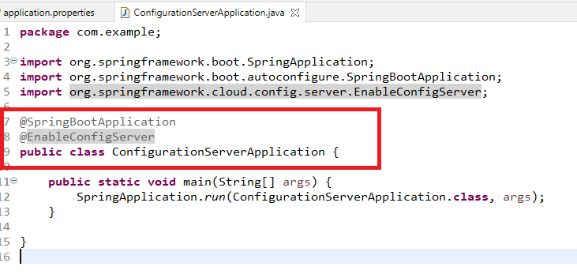

We need to mention the GIT url in the application.properties/yml file

application.properties

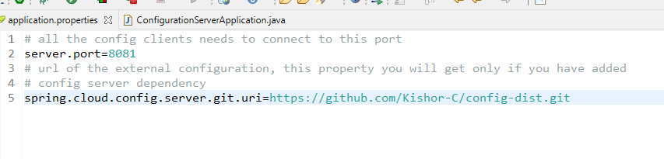

You can launch the configuration server and wait for the config clients to connect

Now the clients can connect to 8081 and pull any configuration files like app.yml, app-dev.yml and so on.

URL the client must use is: <http://localhost:8081/>

Note: Client need to load the configuration file before application.properties, hence this URL needs to be written in bootstrap.properties

Config Client Project

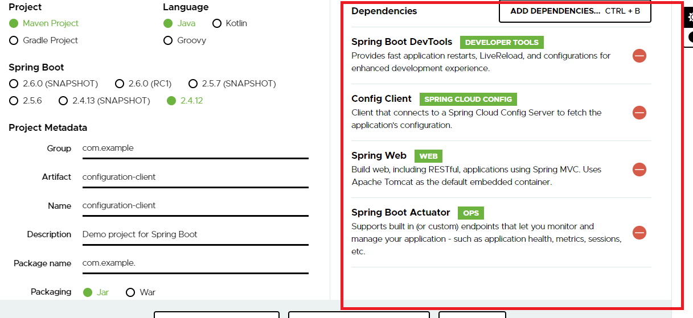

Actuator: This helps in monitoring the application and also you can get the updated configuration from the cloud without reloading the application using the actuator endpoints like refresh.

Change the spring boot & cloud versions to be compatible

bootstrap.yml

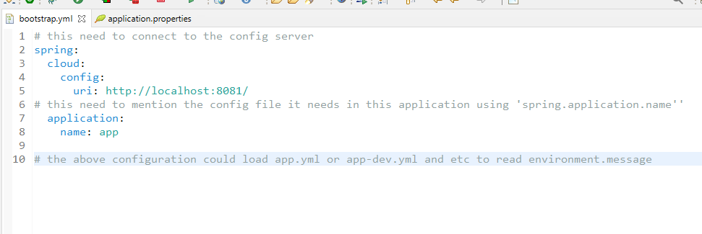

Now once the application is launched it loads app.yml, you can also have application.properties to mention any specific configurations related to the application

application.properties

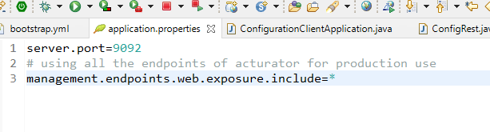

This application loads app.yml but you need to read the property in your application using ${environment.message} in any of the property

ConfigRest.java

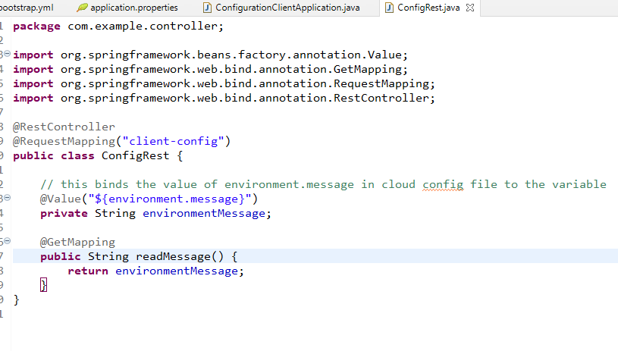

Here just for demo purpose we are binding the values of the external properties to the variable to see the output via Postman

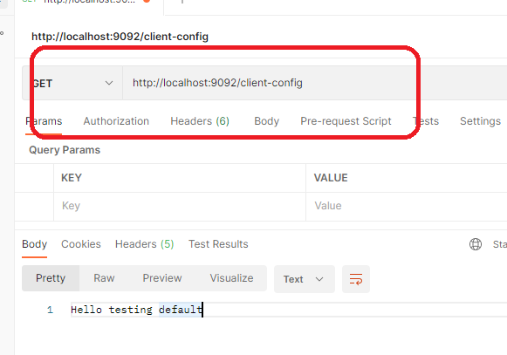

The above value is present in app.yml, however you can change the profiles and load app-dev, app-test, app-prod accordingly.

bootstrap.yml

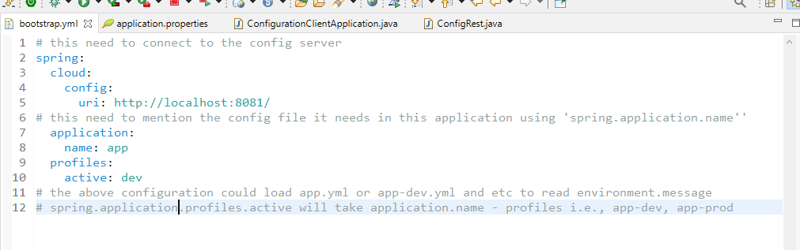

Note: You can provide profile names at runtime also using command line, like java -jar file-name.jar --spring.profiles.active=dev

Output:

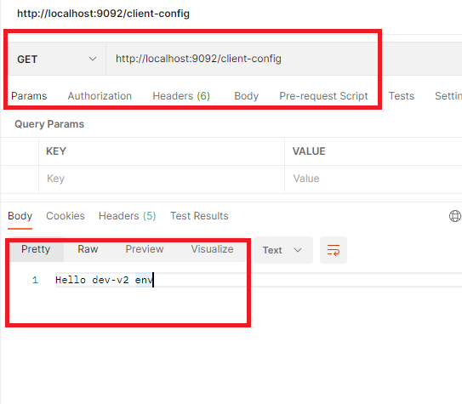

Exercise:

Configure the datasource information like driverclass, url, username & password in the external file and in client config use it through config server, verify you can connect to the database & store some entity using Spring Data Jpa

Hint:

1. Create a yml file in the GIT
2. Config server connects the Git
3. Config Client connects to config server and pulls the YML file
4. Config client should able to using spring data jpa and store some entity

Note: datasource informations must be present in GIT

API Gateway:

It is used to add reverse proxy features where you can have all your microservices accessed via API gateway, which is a front door for all the requests so that you can protect direct access to the microservices by providing a different end point address, it also allows you to use single end point to access multiple microservices.

ex: banking applications may have many microservices independently deployed in different physical address, like account-service, customer-service, loan-service, mutualfund-service, insurance-service, if these have different names & end point then the client need to use all the end points of these microservices, here each microservice are independent, so they will have different end points.

In Spring Microservice we need to use Zuul to achieve reverse-proxy feature.

Currently we are accessing First Microservice & Second Microservice with different end point address, like localhost:8081 & localhost:8082 but with API gateway you can use single endpoint to access both the microservice

i.e.,

localhost:5555/api/one -> localhost:8081

localhost:5555/api/two -> localhost:8082

(or)

zuul-service/api/one -> localhost:8081

zuul-service/api/two -> localhost:8082

Assume zuul-service is the logical name registered in service discovery.

Creating the API gateway

pom.xml

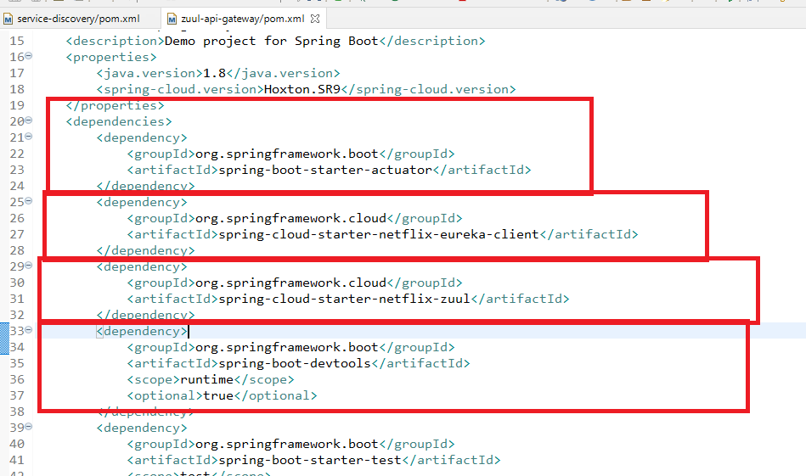

Note: This is not going to act as a microservice but it can be registered in the service discovery in application.properties.

Use @EnableZuulProxy: This creates an API gateway to accept the request coming to it and route to the appropriate services

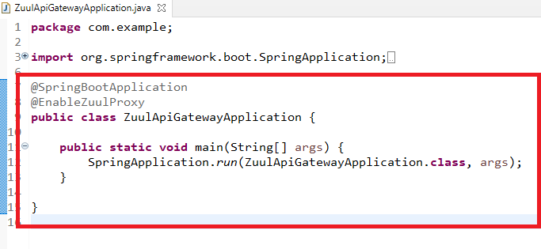

bootstrap.yml

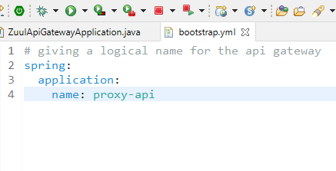

Note: proxy-api is the common endpoint which can be used by all the microservices to communicate with other microservices through the API gateway

Configuring the routes for the services with different end point address.

application.yml

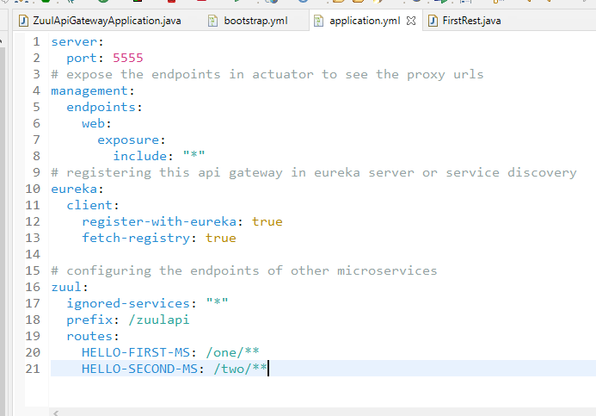

You need to run

1. Service Discovery
2. First Microservice
3. Second Microservice
4. Zuul Api Gateway

You can observe the eureka dashboard having all these instances

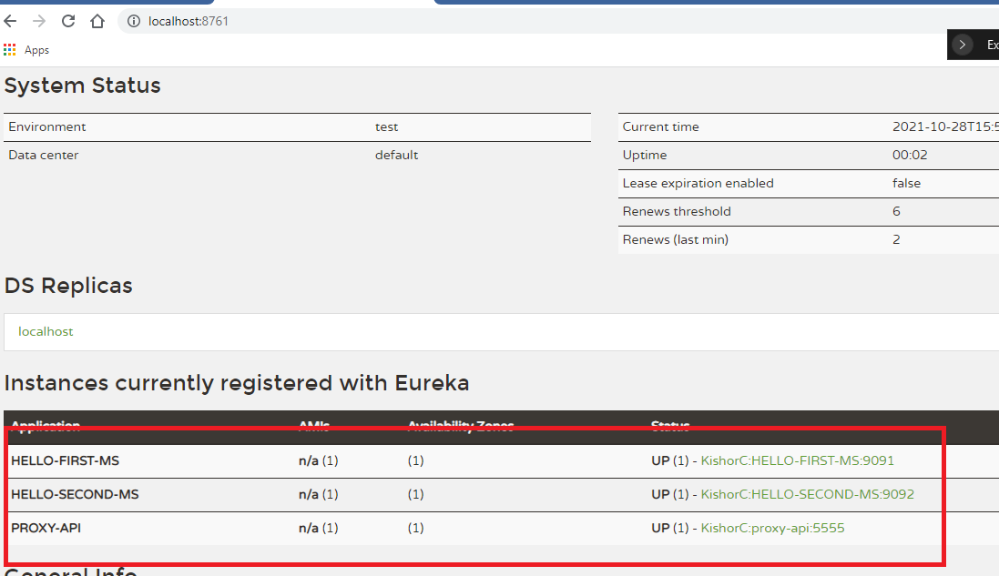

proxy-api is the common end points, the microservices can use to call other microservices

Earlier end point the microservices need to use was:

<http://HELLO-FIRST-MS/first-api>

Now the end point microservice need to use will be:

<http://proxy-api/first-api>

<http://proxy-api/second-api>

But to test you can directly use the physical location of api gateway

<http://localhost:5555/one/first-api>

<http://localhost:5555/two/second-api>

Since the postman is not a microservice we need to access the API gateway with physical address

Inorder to see the routes configuration of api gateway you can use routes end point of actuator

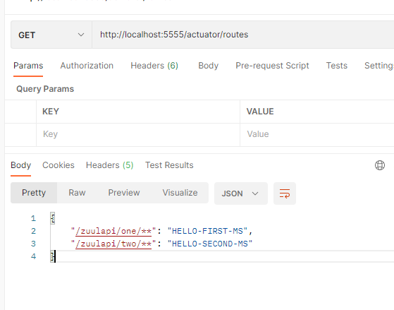

To call the first or second microservice earlier you had used different endpoint, but now you can use zuulapi/one/first-api & zuulapi/two/second-api

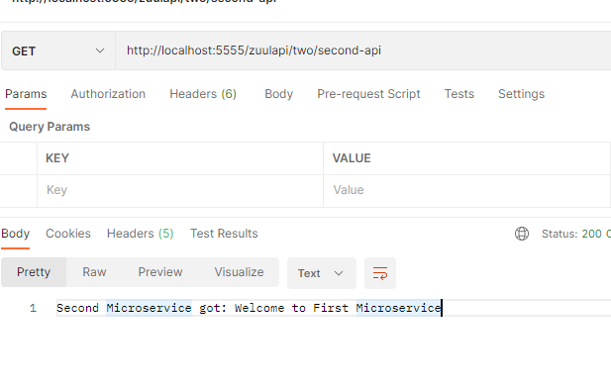

Circuit Breaker with Reslience4j

In this you will handle failed services to avoid cascading of failures, because if any one remote service is down then the client service would wait for the response for certain time, while it is waiting the client might be processing other clients which would also be waiting for the response, after certain period of time too many requests would fill up the resource and the client also might go down which leads other clients also to go down gradually, to avoid this we need to break the circuit when the service is slow/down, so that the clients could respond with alternate response till the remote service comes up.

Resilence4j is the library which allows to handle the failed services, it uses some state machine which will have 3 states

1. closed
2. open
3. half-open

CLOSED: the request would go to the remote service

OPEN: the request wouldn’t go to the remote service, instead an alternate method will be called until the circuit is HALF-OPEN/FULL OPEN

HALF-OPEN: After certain wait duration, circuit would be in half-open, which can send request to the remote service to get the response, if remote service is not up, then the circuit would go to OPEN state again after some threshold limit, if in case the remote service responds then circuit would be closed after certain successful response i.e, when failure rates are below the threshold limit.

Resilience4j uses Ring Bit Buffer, to maintain the thresholds.

The circuit would be open/half-open/closed only if the condition on ring bit buffer is satisfied

Dependencies required

1. Resilience4j
2. AOP
3. Actuator

We will add these in the existing project of second microservice

pom.xml

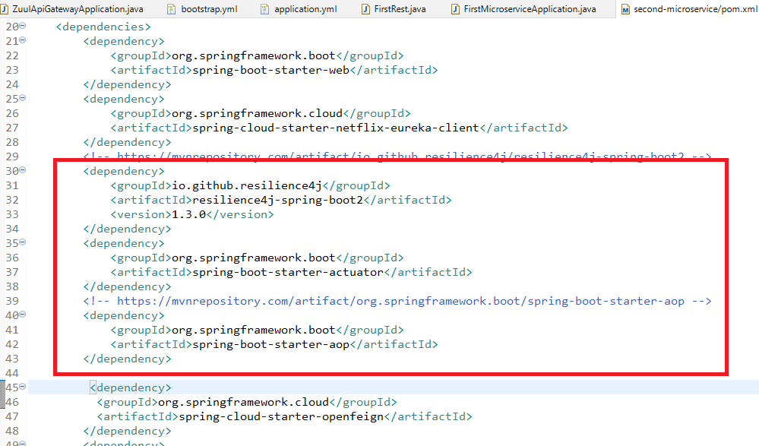

Create a service layer in the second microservice that calls the first microservice

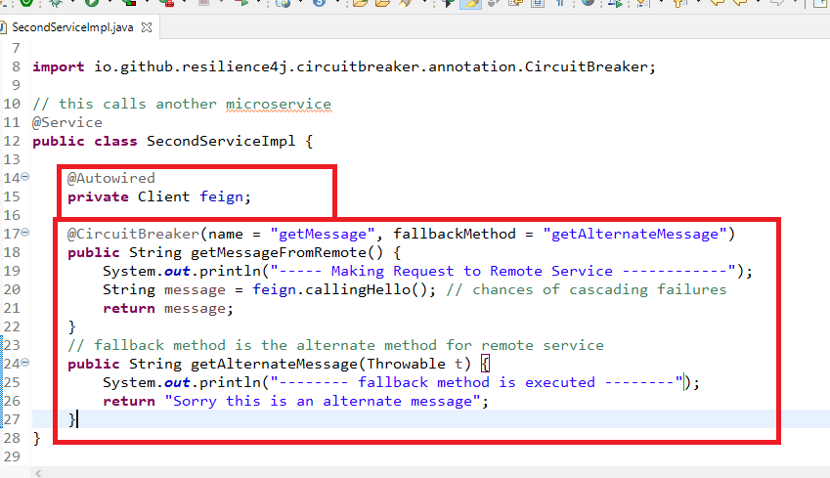

Modify the second microservice rest controller to call the getMessageFromRemote

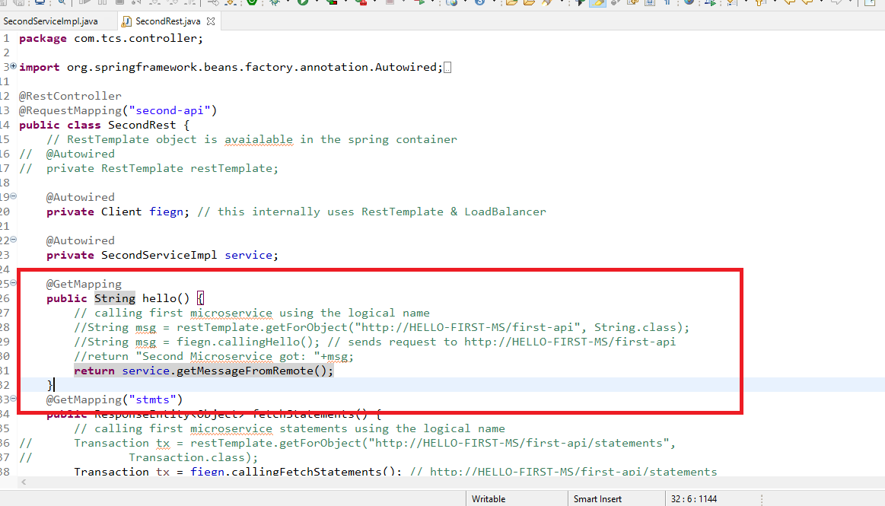

You need to configure the application.properties to apply the circuit breaker configuration

application.properties

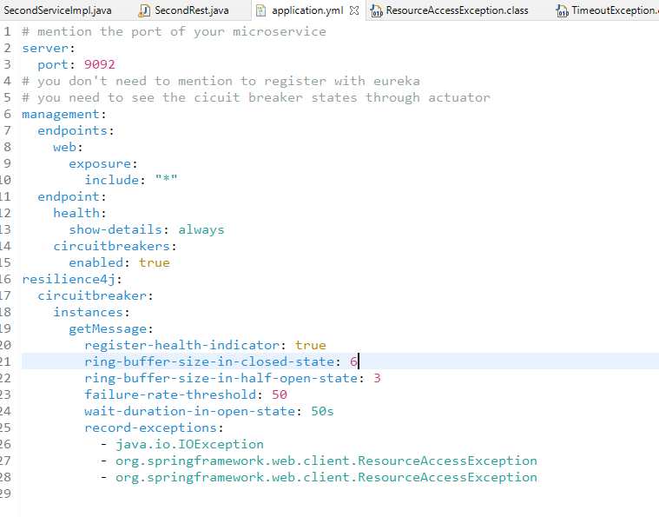

You can use actuator/health to see the circuit breaker state.

Note: Earlier spring microservice used Hystrix to use circuit breaker pattern, but Hystrix is deprecated, hence we are using Resilience4j

Summary

Different types of Architecture styles

1. Client Server (2-tier, 3-tier), tier means physical separation of the systems, like server, database, files, message queues and so on
2. Layered architecture: logical separations like service, dao, controller, view
3. Distributed applications: you can remotely access them
4. SOA: Service Oriented Architecture, webservices are used i.e., SOAP, to integrate applications
5. REST: REpresetational State Transfer, REST based webservices, you can integrate any kind of applications, using URL & HTTP methods
6. Monolithic: All the modules / services will be in single build file
7. Microservices: Services are independently deployed

Overview of Microservice

* Easy to develop
* Easy to maintain
* Easy to deploy
* Easy to test
* Easy to modify

Limitations of Microservices

* Right skill set people with various domain knowledge, like development, testing, production (DevOps)
* Challenges in debugging
* Complexity increases when too many microservices communicate with each other
* Cost of investment will be higher

Thumb rule to go with microservice

1. Follow 12 factor app
   1. Single repository for all types of deployment
   2. Dependency management

Refer this url: <https://12factor.net/>

1. REST principles
2. Domain Driven Design
3. Ball of mud: follow strictly all the design patterns to avoid common issues
4. Various patterns of Microserivces like
   1. Service Discovery
   2. Circuit Breaker
   3. Load Balancer
   4. Distributed Tracing: to log the microservice flow
5. Transaction management: Saga Pattern, Event driven approach
6. Message Brokers/Message Queues: Intermediate storage locations of data if the end applications are not available

Consumer < ---MB/MQ--- > Producer

1. Testing the services using some REST assured libraries, which is used to test the Microserives/webservices
2. Security: Using OAuth & JWT, protecting the unauthorized access
3. Docker & Kubernates: To deploy the microservices on cloud.

Reference Documents on Spring Microservices

<https://spring.io/projects/spring-cloud>

Reference Document on Microservice

<https://microservices.io/>

Distributed Tracing: This allows multiple microservice to log the messages when they are communicating, it makes developers to know where the failure happened, since microservices are deployed in different locations, we need distributed tracing technique, in spring cloud we have Zipkin & Sleuth to manage the logs of microserivces.

API Gateway with Zuul:

Common door for all the requests coming to the microservice, you can provide reverse proxy features like different URL instead of original URL

Circuit Breaker

1. Hystrix (Deprecated)
2. Relsiliency4j

Rest Assured:

It is a unit testing methodology, which allows you to test the webservices & microserivces.

Unit testing:

An independent component is nothing but an unit, that can be tested using unit testing framework, in Java we have Junit, to test the individual components,

same Junit is used in RestAssured to test the services with some of its static methods.

Note: To use RestAssured in microservice you don’t need any dependencies because they are by default added.

In every project you will have a test folder which can have the test cases

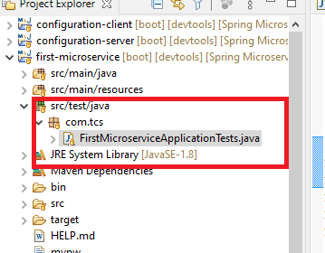

How to write the test cases

1. You must have a method with @Test, this is executed when you run the test cases
2. @Test must be part of @SpringBootTest & @AutoConfigureMockMvc

@SpringBootTest: It is a collection of test cases

@AutoConfigureMockMvc: It mocks the server and all the configuration required for spring like spring container, dependencies and so on, You don’t have to run the microservice & register in eureka server at the time of testing.

src/test/java

FirstMicroserviceApplicationTests.java

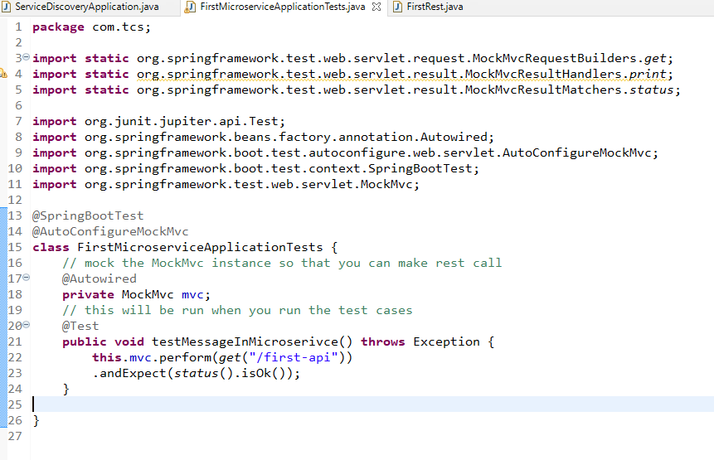

Right Click on the File -> Run As -> Junit

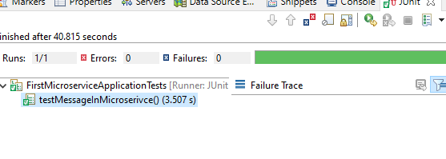

You also print the result using print() & expect a specific content which is static method

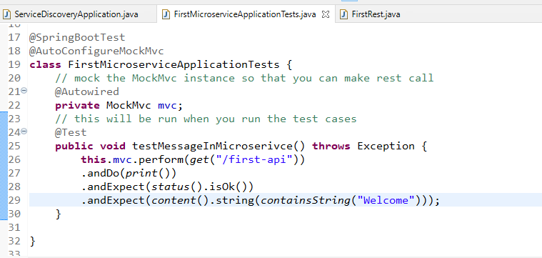

Security:

It allows you to protect the services from unauthorized user, you can protect your services via spring security using 2 main principles

1. Authentication: Identifying the right user (logged in)
2. Authorization: An authorized user having only specific privileges/roles (ADMIN, GUEST and so on).

Security is implemented using OAuth2, which would generate some token when user/application authenticates, OAuth would also verify the user is authorized or not while accessing specific service

Auth Server: It is a server that generates the token for the authenticated user and the application, this token is used by the user & the application to access the microservice,

Microservice would send the token to Auth Server whenever user & application tries to access the microservice, if the token is valid it means that the microservice is accessed by authenticated & authorized user, else auth-server would respond saying invalid/unauthorized.

OAuth Token: This will have authenticated user and application data so that every request doesn’t need user & application credentials, token is internally sent to OAuth server to make users life easy.

Note: As a user we only enter username & password but behind the scene we are using a client application to access the service, this client application must also be registered in the Auth Server, so that the Auth Server generates the token for both user & client application.

Spring users OAuth2 to implement security, which is a token based authentication framework, by default OAuth server generates a OAuth token which is doesn’t have any standard, but it can use other type of tokens like JWT (JSON Web Token), which follows some standards in security like digital signature, tampering and so on.

Spring Security uses 4 components

1. Protected Resource: A microservice
2. Resource Owner: Grants permission for the user based on the roles
3. An Application: client application that user uses.
4. Auth Server: Authentication Server which can generate & validate the token.

We need to create 2 projects mainly

1. Authentication Server: Who takes the user & application credentials & generates the token & validates
2. Microservice/Protected Service: Who connects to the Authentication Server to validate the token, it will have webservices that can be accessed only by authenticated & authorized user

Authentication Server

pom.xml

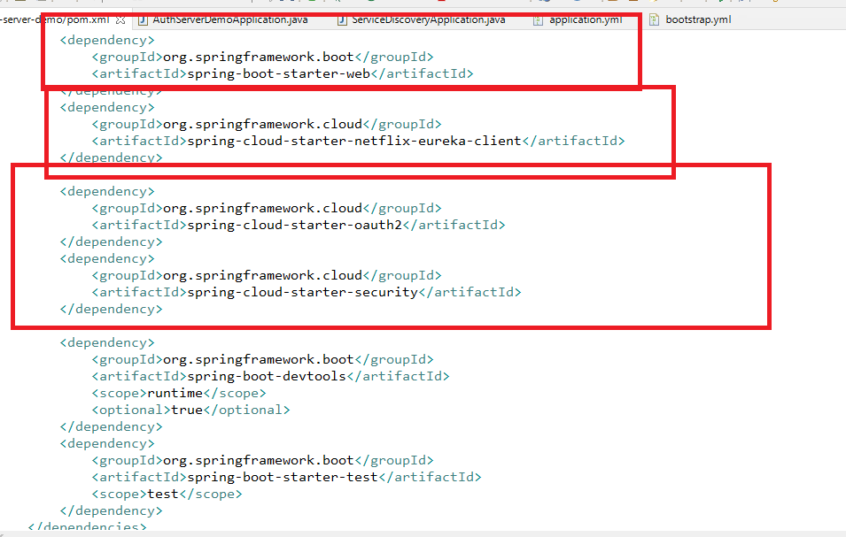

bootstrap.yml

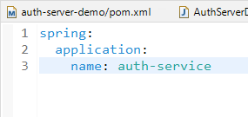

application.yml

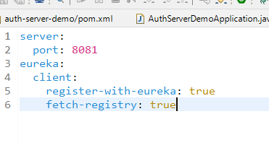

Program to create an auth server that can generate & receive the token from the protected resource

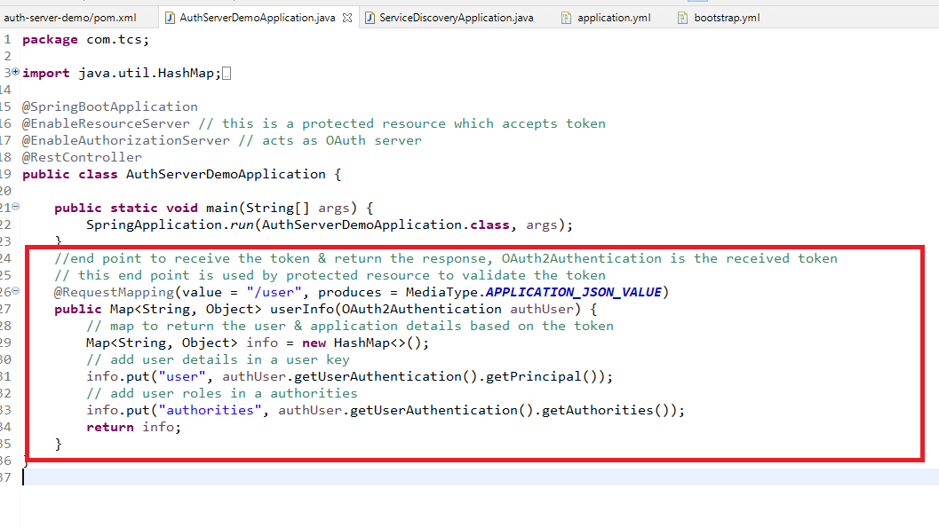

/user is the endpoint the microservice must use inorder to send the token from their application.yml file

Spring Security uses some configurations for

1. User -> username & password
2. Client Application -> name & password, scope, gran types must be configured

Since we don’t have client application, we only need to generate the token in POSTMAN and add that token while accessing the resource

In Postman you have some header properties which you need to configure

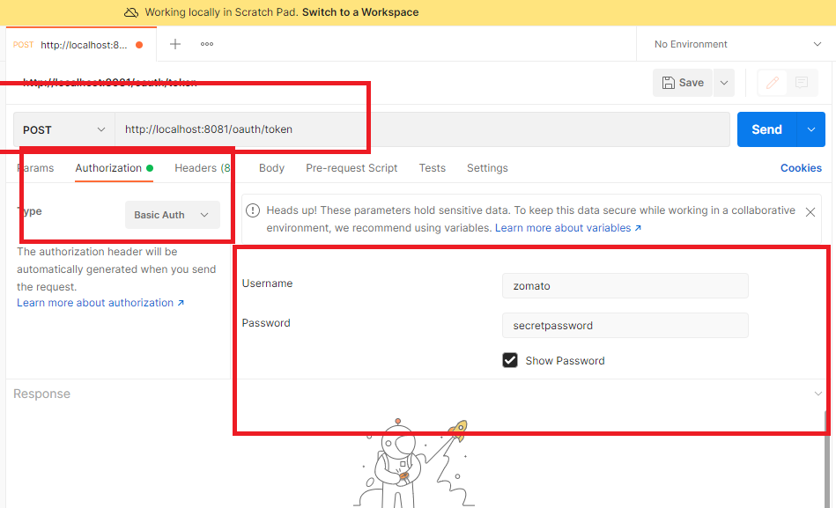

Here the URL is used by client applications behind the scene, it passes Type Basic Auth, with username & password of the client application & along with that it has to pass user information in form parameters

For the same url you need to configure the username & password of the end user along with the scope & grant_type of the client application

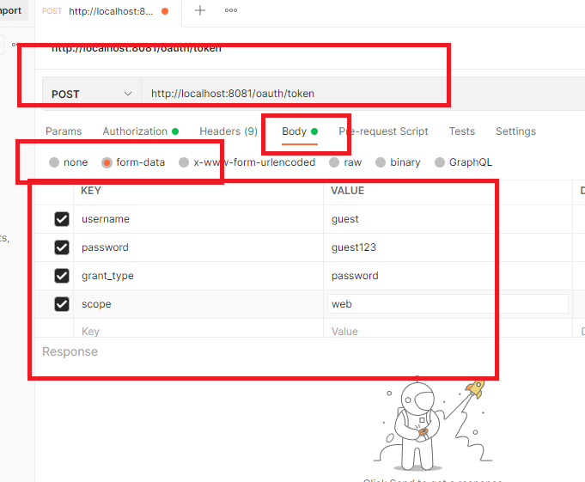

Now a token will be generated for the guest

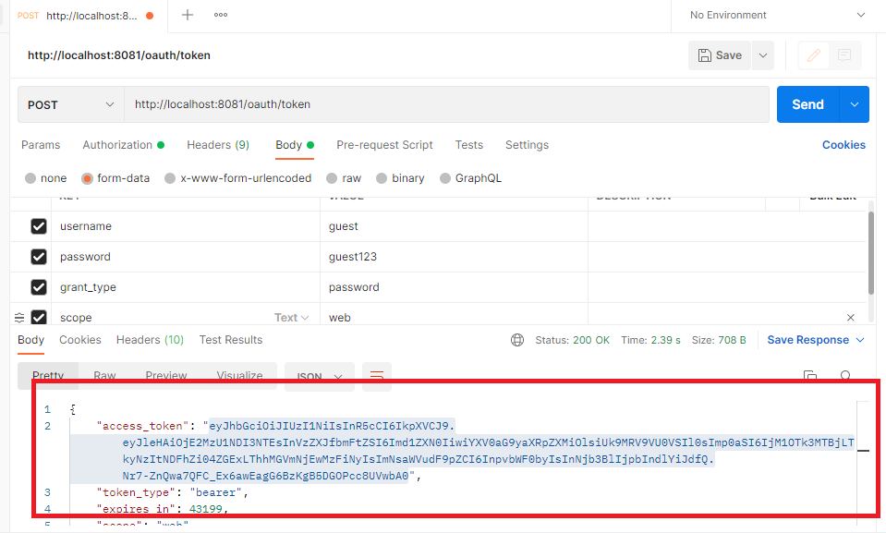

The above token is passed in the request header while accessing the protected resource, we the token is modified/token is not present then protected resource gives error.

Another token for super.user

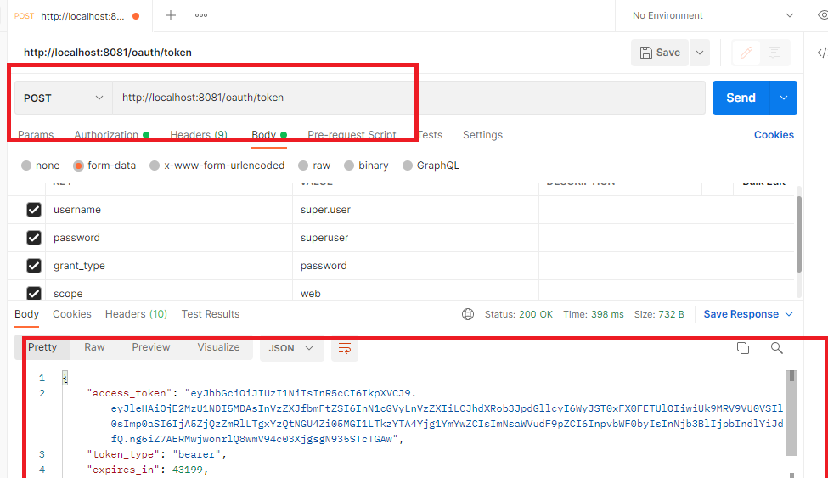

The client application stores the token and passes in the request header while accessing the protected resource.

Accessing the protected resource with the token, the client application needs to configure the authentication type & mention the token - all these are done internally.

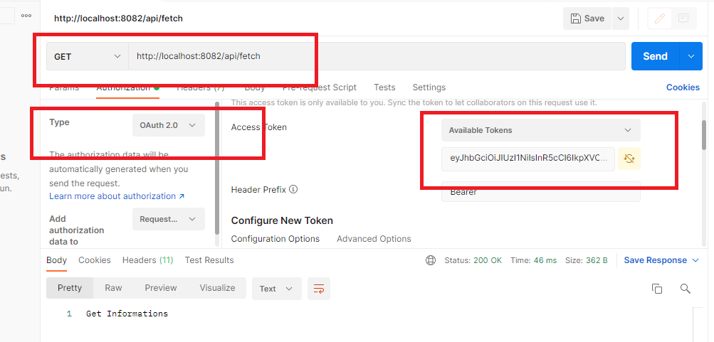

Since the token belongs to guest, you can’t access POST, doing so will be an error

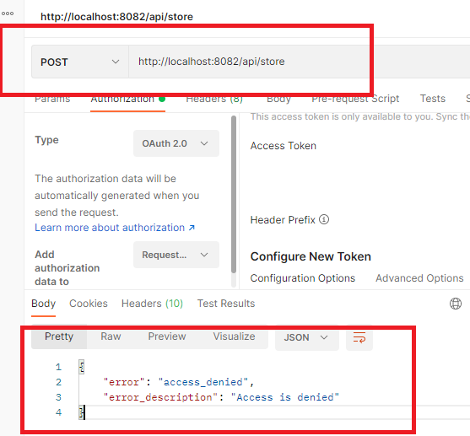

But the same POST can be access by the super.user, protected resource needs that token.

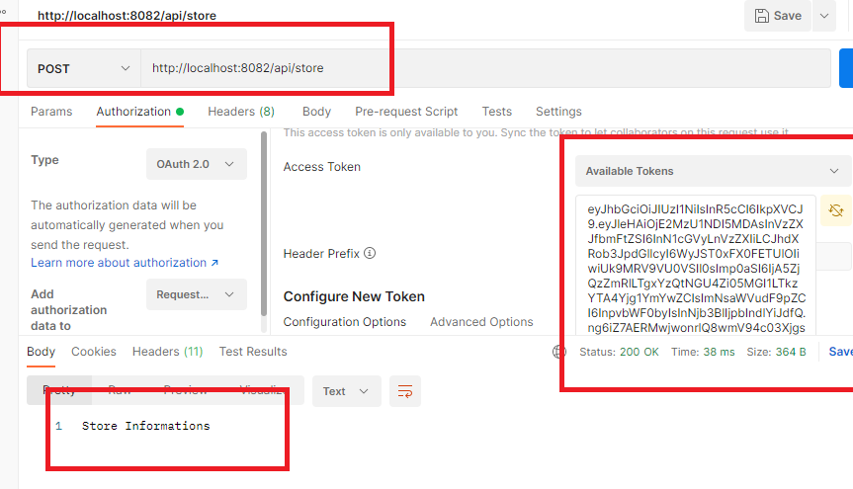

How to deploy spring microservices on cloud, so that they are accessible over the internet

We have many ways to deploy applications on cloud

1. Manual installation of all the necessary softwares in the cloud machine & deploying the application by sharing the build file through some ways like GIT, SVN, S3 bucket an so on
   1. You will create an executable jar in local machine, you will push the jar to the git
   2. You will access the cloud machine, install git & pull the jar form the git
   3. You will install all the necessary software
   4. You will run the jar
2. Using Docker & Kubernates: With Docker & Kubernates you can run the application on cloud without installing any softwares

Docker: It is used to run the application in its own container, where all the necessary libraries & softwares are present in the container to run the application, you don’t have manually install any software

Kuberanates: It will automate the configuration of docker, so that you can scale up or scale down the numbers of containers you need

Docker is a software that can run your application on any platform without having any necessary libraries or softwares.

ex: To run spring boot application you need to have JRE, spring jars, but if you use Docker you don’t need any thing at all.

Because docker uses docker image which is a template that will have all the configuration to run the application like libraries & softwares.

Docker image: It is created using Dockerfile, which will have all the configurations to run the application, you need to create the image and run in the docker engine

Docker vs Kubernates:

In Docker you will containerize manually like starting, stopping the applications

In Kubernates everything is automated.

Docker can be installed in windows, macos or any other machines, but its advisable to install docker in cloud machines as you want to launch application on cloud.

How does the docker work.

1. You need to create the application with Dockerfile and mention all the configurations required to run the application like java8, java -jar app.jar and so on
2. You need to create an image from the docker file
3. You need to push the image to the Docker hub, it is a website like GIT keeps docker images that can be pulled from anywhere
4. You need to register in the docker hub to push/pull the images
5. You need to install docker in the cloud machine and pull the docker images & run it on the cloud.

Points to remember

1. you must have docker hub account
2. You can push/pull docker images from the command line only after you login in the command line
3. You can use AWS EC2 instance to create one remote machine

What is EC2 (Elastic Cloud Computing)

1. It is a remote machine available on cloud, which can be accessed via terminal through GIT bash you can access